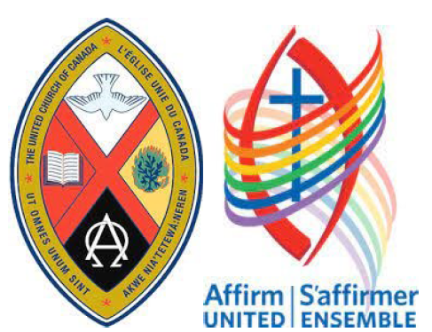

Ralph Connor Memorial United Church

Annual Reports
2025

Annual General Meeting
March 22, 2026
Canmore

ANNUAL GENERAL MEETING
AGENDA
1. Call to order by Rev. Marco Ste-Marie and quorum count
2. Motion to allow all attendees to vote
3. Motion to approve or amend the agenda as circulated
4. Opening Prayer by Rev Marco Ste-Marie, noting 2025 Passages
5. Holy Manners
6. Motion to appoint Chair and Secretary of the Annual General Meeting
7. Remarks by the 2025 Chair of the Council of the Ralph Connor Memorial Community of Faith
8. Motion to Adopt Minutes of Annual General Meeting held March 16, 2025
9. Motion to receive the Reports of the Ralph Connor Memorial Community of Faith as listed in the Table of Contents
10. Motion to approve the 2026 budget of the Ralph Connor Community of Faith
11. Motion to appoint Financial Review Agent for 2026
12. Motion to approve the 2026 budget of the Canmore Young Adult Network
13. Motion to approve the 2026 budget of the Bow Valley Refugee Project (BVRP).
14. Motion to approve the 2026 budget of the Green Exodus
15. Motion to approve the Memorial Fund Wish List 2026
16. Elections:
a. Board of Trustees, Ralph Connor Memorial United Church
b. A motion from the Council on the make-up of the new Council.
c. Community Council, Ralph Connor Memorial United Church
17. New Business
a. A motion from the Council on the work of the ad hoc research team exploring our Journey into the Upper Bow Valley.
b.
18. Adjournment
ANNUAL REPORTS FOR 2025
TABLE OF CONTENTS
Agenda (Ian Schofield & Ruben Nelson) 1.
Reports 4.
Minutes of the 2025 Annual General Meeting (Ruben Nelson) 5.
Passages (Rev. Marco Ste-Marie) 10.
Chair’s Report (Ian Schofield) 11.
Minister’s Report (Rev. Marco Ste-Marie) 15.
Reports of the Internal Ministries of the Ralph Connor Community of Faith
Communications (Jim McPherson) 17.
Ministry and Personnel (Joy McMann & Ian Brownlie) 19.
Pastoral Care
- Benevolent Fund (Rev. Marco Ste-Marie) 21.
- Healing Pathway Prayer Circle (Val Goodrow) 22.
- Pastoral Care (Ruby Fisher) 23.
Spiritual Explorations
- Kids Connection (Cathy Harrop) 24.
- Spiritual Explorations (Isabelle Ramsay) 25.
Stewardship
- Stewardship (Rick Anderson) 26.
Wider Church
- Chinook Winds Region (Allan Buckingham) 27.
Worship
- Music (Tanya Sullivan) 28.
- Worship (Janis Dougall) 29.
Reports of the Community Ministries of the Ralph Connor Community of Faith
Affirming Ministry 31.
Aline Voices Threshold Choir (Jan Tissandier) 32.
Bow Valley Wedding Ministry (Rev. Keith Murray) 33.
Bow Valley Refugee Project (Karen Fraser) 35.
Canmore Young Adult Network (Nicole Eplett) 36.
Ecumenical Prayer Shawl Ministry (Mona McIntyre & Jeanette Aishford) 37.
Friends of CYAN (Joy McMann & Ruben Nelson) 38.
Futures Exploration (Joy McMann) 39.
Green Exodus (Sarah Arthurs) 40.
Reconciliation (Joy McMann) 41.
Rundle Thrift (Sally MacDonald) 44.
The World is Our Neighbour (Ian Brownlie) 45.
Worship
- Evensong (Jan Tissandier) 47.
Reports Regarding Physical Assets
Board of Trustees (Carole Rowe) 48.
Building/Heritage (Paul Elfner) 50.
Historian/Memorial Fund (Karen Fraser) 51.
Annual Financial Reports and Budgets (Bill Fisher, Patricia Roozendaal)
Treasure’s Report 53.
- Long Rang Capital Plan 68.
Bow Valley Refugee Project 74.
Canmore Young Adult Network 76.
Green Exodus 81.

REPORTS

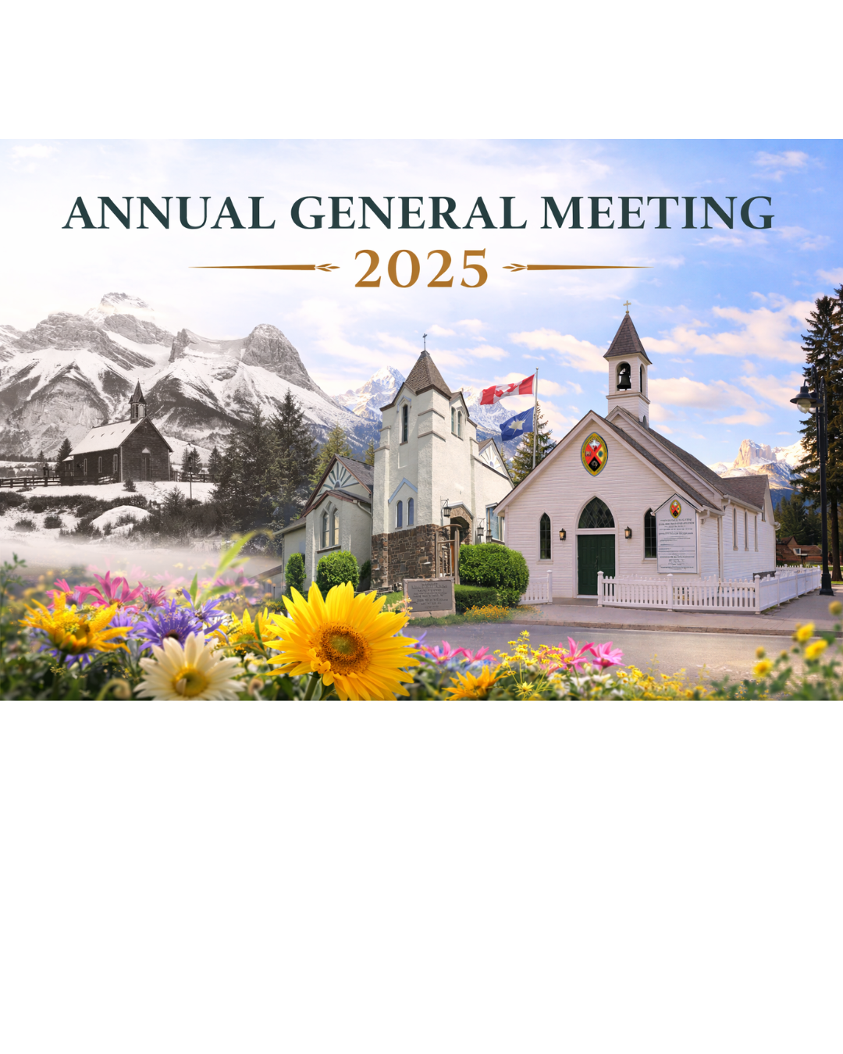
RALPH CONNOR MEMORIAL UNITED CHURCH COMMUNITY OF FAITH

Our call and purpose as a community of faith is:
- To nurture the spiritual exploration and growth of all our members and adherents;
- To be an intentionally inviting Christian community that seeks, welcomes and embraces new members;
- To reach out and become an agent for social justice in our neighborhoods and in the global community.
As a community of faith on traditional indigenous lands,
- We strive to follow Christ’s example in reaching out in love and friendship to all.
- We are committed to full inclusion of people of any age, race, ethnicity, ability, sexual orientation, gender identity, family structure or personal circumstance, in all aspects of our life together.
- We are called, in and with the larger community, to grow in faith through study, prayer and service, to make known God’s gracious presence, and to show loving concern for all creations.
ANNUAL GENERAL MEETING MINUTES
Sunday, March 16^{th,} 2025 at 11:30 A.M.
Held at Ralph Connor Memorial United Church, Canmore and by Zoom
Present in person: Ellen Andersen, Rick Anderson, Allan Buckingham, Mary Buckingham, Bev Carrick, Paul Carrick, John Cranston, Mary Cranston, Marilyn Foxford, Sharon Fish, Bill Fisher, Ruby Fisher, Faye Forbes-Anderson, Karen Fraser, Don Goodrow, Valerie Goodrow, Peter Hunt, Brian James, Ken LeMesurier, Doris Leavitt, Bob MacDonell, Marilese MacDonell, Mona McIntyre, Cam McMann, Joy McMann, James McPherson, Robert Moranty, Ruben Nelson, Barb Profitt, Carole Rowe, Ian Schofield (chair), Marco Ste-Marie (minister), Heather Snoddy, John Snoddy, Simcha Stroes-Gascoyne, Rod Sullivan, Tanya Sullivan, Marg Suurallik, Janet Trager, Diane Travers,
Present by Zoom: Sandy Penrose
Call to Order and Quorum Count: The Rev. Marco Ste-Marie determined that a quorum was present. He called the meeting to order at 11:38 A.M.
To Allow all Persons Present to Vote:
Motion: “That we allow all persons present, in person or by Zoom, to vote.”
Moved: Rick Anderson Seconded: Karen Fraser Carried.
Review/Revise/Approve Agenda:
Motion: “That we approve the draft agenda as circulated.”
Moved: Jim McPherson Seconded: Allan Buckingham Carried.

Opening Prayer: The Rev. Marco Ste-Marie gathered us in prayer.
Heavenly Father,
We come before You with grateful hearts as we gather for our Annual General Meeting. We ask for Your guidance in all our discussions and decisions. May Your Spirit bring transformation within our church—renewing hearts, minds, and our shared vision for the work ahead. Grant us the grace to grow in unity, love, and service, that our fellowship may reflect the hope and compassion of Christ. Bless us with wisdom, and strengthen our spiritual health so we may shine as a community rooted in faith and equipped for Your kingdom’s purposes.
Amen.
Appointment of the Chair of the Meeting:
Motion: “That we appoint Ian Schofield as Chair of the meeting.”
Moved: Bill Fisher Seconded: Karen Fraser Carried.
Appointment of the Secretary of the Meeting:
Motion: “That we appoint Ruben Nelson as Secretary of the meeting.”
Moved: Ruby Fisher Seconded: Sharon Fish Carried.
At this point, Ian Schofield took the Chair.
To Approve the draft Minutes, v 1.2, of the AGM for the 2023 year of RCMUC:
Motion: “That we approve the minutes of the AGM for the 2023 year of RCMUC as set out in the 2024 AGM Report with these revisions: on page 8, “March” Kennedy will be changed in two places to “Marshall” Kennedy.”
Moved: Joy McMann Seconded: Bill Fisher Carried.
Business Arising from the Minutes of the AGM for the 2023 year of RCMUC: -- No business arising.
Report on the 2024 Year:
- It was agreed that the final version of the Report of the 2024 year would have pictures of both church buildings.
- It was agreed that Lyle Bradley’s name would be added to the list of those who had passed in 2024.
- It was noted that since the Annual Reports were the major historical records of a community of faith it was vitally important that they be complete and accurate.
Receive the reports contained in the Report of the 2024 Year:
Motion: “That we receive the written reports of RCMUC’s Council, Standing Committees, Working Groups and ministries as circulated in the Report of the 2024 Year prepared for this AGM.”
Moved: Bob MacDonell Seconded: Rick Anderson Carried
Financial Statements for 2024:
The Treasurer reported:
- The 2024 financial statements were prepared by Baker Tilly, our accountants.
- A copy has been sent to the CRA along with our T3010.
- The category of “Outreach” is new. It includes both CYAN and Futures Explorations.
- “Deferred revenue” includes all funds we have received in trust for specific ministries. Such funds are not available for our operations.
- The Trustees hold all funds for Long Term Investments.
- We are in a sound financial position.
- Our Balance Sheet is strong.
Motion: “that we approve the 2024 financial statements prepared by Baker Tilly.”
Moved: Carole Rowe Seconded: Allan Buckingham Carried
Appreciation was expressed for the work Bill Fisher has done as our Treasurer and Patricia Roosendaal as our bookkeeper. It was recognized that it has taken a good deal of work to complete the amalgamation of the Rundle and Ralph Connor books, create a new chart of accounts, work with Baker Tilly to reduce their work and costs and get us to this place.
Operating Budget for 2025
The Treasurer reported:
- With the approval of the Council he has prepared separate budgets for our operations and for our capital investments.
- The Thrift Shop is already matching the income it had before the fire.
- Regarding projected expenses:
- We had budgeted $25,000 to cover the minister’s moving expenses. The reality will be less than $2,000. (Applause of thanksgiving for Marco.)
- The rent from the manse in Banff goes to TWION refugee project.
- It is critical that we invest every year in a fund to cover cost of the minister’s sabbatical. We are doing this.
- The net deficit was projected to be $30,000 when the budget was approved by Council in February. We may well break even in 2025.
Motion: “that we approve the 2025 Operating Budget as presented.”
Moved: Jim McPherson Seconded: Cam McMann Carried
The Chair:
- Thanked those who had reviewed the 2025 Operating Budget.
- Noted that in order to keep our charitable status with the CRA we must have a strong group of volunteers at the Thrift Shop.
- Noted the question asked by Sandy Penrose regarding pick-up times in Canmore for items for the Thrift Shop and indicated it will be picked up by the Executive or Council.
Long-Term Capital Planning:
The Treasurer reported:
- The Council had approved his recommendation that we separate capital expenditures from our Operating Budget and engage in Long-Term Capital Planning.
- Our PAR forms and envelopes in the pews will be altered so donations can be directed to our Capital fund.
- After serious reflection the Council had determined that we should proceed with the replacement of the boiler in Rundle this summer when the Rundle Playschool is not active. The actual cost will be closer to $95,000 rather than $120,000. ($5,000 to remove asbestos and $90,000 for the new boiler.)
- The Faithful Footprints program of the UCC is not accepting applications until further notice.
- If requested, the Chinook Winds Region will load us funds: no interest for the first year, then prime +3%.
- The Long-Term Capital Plan as now proposed is in the Annual Report.
Motion: “that we accept the Long-Term Capital Plan as presented.”
Moved: Bob MacDonald Seconded: Rick Anderson Carried
Marco reinforced the significance of our willingness to see, think and act with a long-term sensibility.
The Chair indicated that we will minute our commitment to have a Long-Term Capital Budget presented at each AGM and that each would include plans for how funds were to be raised to meet the commitment.
Expression of Thanks to Marlo Reid-Gibson:
The Chair expressed deep thankfulness to Marlo Reid-Gibson for her heroic work as Chair of Property. As such she handled a vast amount of work immediately following the fire in the basement of Rundle and in the 12 months afterwards. We really have no idea how much pain and agony she bore as she kept us from having to struggle with these matters as amateurs.
Volunteer Hours:
The Secretary noted that the UCC is now collecting the number of volunteer hours invested by the members of each community of faith. Our total for 2024 was roughly 6,000 hours.
CYAN Budget for 2025:
The Secretary noted that the Friends of CYAN, which Joy McMann Chairs, meets with the Executive Director of CYAN in order to keep up with activities, keep current on the budget and income and provide support as needed.
Motion: “that the CYAN budget for 2025 be approved as presented.”
Moved: Bill Fisher Seconded: Joy McMann Carried
BVRP Budget for 2025:
Motion: “that the budget of the BVRP be approved for 2025 as presented.”
Moved: Karen Fraser Seconded: Cam McMann Carried
Memorial Fund:
The Chair noted that items invested in by the Memorial fund must be “visible and enduring.”
It was the sense of the meeting that:
- The Secretary provide Council with a list of the items that had been agreed upon at past AGMs and of any policy governing the use of the Memorial Fund.
- This matter referred to Council.
Election of Trustees:
The Chair of the Trustees indicated that all Trustees were willing to serve for another year.
Motion: “that we nominate and elect all existing Trustees for another year.”
Moved: Carole Rowe Seconded: Allan Buckingham Carried
Election of Council:
The Chair indicated:
- Almost all members of Council were willing to serve for another year. Living in Right Relations is the exception.
- The Council has the authority to fill vacancies.
- Current vacant positons:
- A 2nd Representative to the Chinook Winds Region
- Living in Right Relations
- Food and Friends
- Healing Pathways
- Up to three members at large.
Motion: “that we nominate and elect all existing members of Council for another year.
Moved: Bill Fisher Seconded: Jim McPherson Carried
The Bell at Ralph Connor:
The Chair announced that Peter Hunt has agreed to see what needs to be done to get our bell into good working condition, if possible get it done, and teach those who are interested in the art of bell-ringing.
Adjourn: On a Motion by Bill Fisher the Chair adjourned the meeting at 12:56 P.M.
Minutes Prepared by
Ruben Nelson
Secretary

Please draw to his attention any errors or omissions.
403-609-1016, cell
rubennelson@shaw.ca

PASSAGES
Rev. Marco Ste-Marie

Maureen Flight, Oct 1931 November 2025

CHAIR’S REPORT
Ian Schofield
Chair of Council
This report focuses on several initiatives of Church Council which occupied much of our attention in 2025 and which underpin our success as a Community of Faith. We are thankful that we have a talented and hardworking community of faith which quietly and confidently responds to needs as they arise.
Capital Plan Implementation
Our church in Canmore, now known as Ralph Connor Memorial United Church, was built as soon as Rev Charles Gordon (pen name, Ralph Connor) arrived in the Bow Valley. The first service was held on January 25,1981. We are proud that our present Sanctuary is 135 years old and has been kept in good condition. Rundle Memorial United Church held its first service in our present Sanctuary in Banff on July 1, 1927. (There was an earlier Church on the site erected by the Methodist Church in 1893.) Both churches throughout all the years offered Christian worship and provided the wider community with a place to meet, learn, socialize and recreate. We want to continue that heritage.
In 2025 this Community of Faith started implementing a Capital Plan to ensure that these buildings remain safe, accessible, available and viable, The goal of the Plan is to refresh and maintain both our campuses with regular maintenance, repair and renovation within a separate budget. In 2024 under the guidance of Bill Fisher as Treasurer, we adopted a multiyear plan to finance, renovate, repair and maintain the historic structures and new additions.
At Rundle in 2025 the old boiler system from 1927 was replaced. We now have steady, efficient and environmentally sound furnace and water heater. Many thanks is extended our boiler whisperer, Brian James for his years of maintaining our ancient systems. At Ralph Connor our wonderful Property Guys supervised the exterior painting as required by its historical designation and repairs to the bell tower. Once again, the sound of our bell ringing on Sunday mornings and special occasions is heard in the downtown of Canmore drawing visitors and locals alike to our presence. Isabelle Ramsay, Chair of Spiritual Explorations, championed the painting of a vibrant mural in the Courtyard and in front of the steps to the Narthex. The next Council is urged to follow the Capital Plan and revise and augment the Plan well into the future.
Community Partners use our facilities
In 2025 we attracted more community agencies to our buildings for their community work. Important community partners continue to use our campuses to serve the Bow Valley. Rundle Playschool continues to operate from Travers Hall after 51 years. Our newest refugees, a Christian family of three, who arrived in the summer from war torn Syria, are living in the Manse. The Thrift Store was reopened this past spring and is thriving in the post fire newly renovated space. Thanks is extended to Sally McDonald and Ian Brownlie on a successful relaunch of the Thrift Store.
The Rundle Sanctuary Team was established to explore reimaging the Sanctuary to better use this space both for Worship and Christian celebrations and for the wider Banff community. Under the direction of Reverend Marco Ste. Marie, the Team is asking lots of questions, considering lots of options, and consulting lots of outside agencies and funders. This work along with input from the Into the Upper Bow Valley Working Group led by Ruben Nelson and Joy McMann will ensure we are good stewards of Rundle Memorial and the Upper Bow Valley. As the community continues to emerge from the chill of Covid, we are seeing more interest in using Ralph Connor Memorial. Thanks to Cam McMann we have fine-tuned our renting procedures to meet this developing need to be a source of revenue at affordable prices.
Mission Work
Our community of faith continues its mission work outside our two campuses. Over the last few years, we have started a practice to partner with outside agencies and community members to spread our mission work into the community. We are a community rich in human resources. We identify a need and coalesce a team of committed congregants to plan our response. We reach out into the community to find neighbours, who may not share our faith; but who share our values and work with us to provide a response to crying needs.
Our community of faith founded CYAN, Canmore Young Adults Network to provide responsible social, recreational and learning opportunities to young adults, age 18-35 residing in Canmore and now into Banff and the upper Bow Valley. CYAN is semi-autonomous organization. Our community of faith through Friends of CYAN act as a sounding board and serve as fiscal trustee providing accounting and budget review. We are their interface with CRA. Similarly, we founded Bow Valley Refugee Project over 10 years ago. Again, the community of faith acts as fiscal trustee. We have broadened our volunteer base with community members and worked with other groups to settle 11 refugees as we await the arrival in Canada of 7 more. The Prayer Shawl ministry led by Church members together with an army of community knitters make cozy, wool shawls to distribute throughout the Valley to comfort those facing medical and other personal challenges.
This model of partnering with other agencies and community members works, allowing us to broaden and deepen our mission work. Our community of faith has taken steps to partner outside our congregation in the areas of Right Relations and our Affirming Ministry. Thanks are extended to all involved in these initiatives.
Worship
Central to our Church life is worship, prayer and study. We continue to respond to the worship needs of our community of faith with a traditional Sunday morning worship with musical offerings by our exceptional Choir and talented soloists and combos, contemplative Evensong service on Wednesday evenings and a variety of worship expressions such as drumming and sacred dance. Isabell Ramsey and her team have been working hard regarding spiritual explorations. We offer a Prayer Circle. Healing Pathways has been revived. Reverend Marco is offering services twice a month at the Bow River Lodge assisted by another of our congregation / community initiatives, the Threshold Choir. This Council supports this wide offering of worship expression and thanks all who are involved.
Reverend Marco
The big event of the year was the arrival of Reverend Marco Ste. Marie as our new full time minister. We spent the year working into this relationship as we got to understand each other. We are all richer for this experience. There is positive dialogue between Council and Reverend Marco as we deal with emergent issues and together work on our future. We are excited that we will journey together for years to come. Thank you, Marco, for accepting the call to minister this community of faith.
Thank You
A big thank you is extended to all who are concluding their Council responsibilities, Paul Elfner, Jim McPherson, Mary Buckingham, Karen Fraser, Rick Anderson and Marlo Reid. Some will continue to be active with committee work or special projects. We thank Marlo Reid and Paul Elfner who will continue to work on the Property and Capital Projects Committees. Ian Schofield will take on the position of Church Historian. For those who are stepping off Council may your leadership skills and experience lead you to volunteer on a Council Committee or Team Ministry when you are spiritually refreshed.
Thank you to Ruben Nelson (Secretary), Bill Fisher (Treasurer), Joy McMann and Ian Brownlie (Ministry and Personnel), Carol Rowe (Chair of Trustees), Janis Dougall (Worship), Isabelle Ramsay (Spiritual Explorations) and Alan Buckingham (Rep to Chinook Winds Region). It is so important to have experienced members of Council to ensure continuity and guidance to new members who are entering into leadership roles.
To those who are continuing their work as Team Leaders and as members of our Ministries, thank you for your time and enthusiasm. To those who are stepping back from ministry work, thank you. You will be welcomed back with enthusiasm when you are ready. Until then you remain a dear member of our community of faith and your presence and prayers are so appreciated.
Reflections
This is my last Chair’s Report. After eight plus years as Chair and several years in other roles, it is time for new leadership. I will continue to serve on Council as Church Historian. I offer my wisdom gained from my terms as Chair. I am very thankful for our collective work as a Council and as a community of faith over the time I have served as Chair. We have experienced many challenges; but now we have a solid financial position, two very serviceable and increasingly active campuses and a compassionate, dedicated, friendly and caring community which partners with other communities to live out our missions. We are so fortunate to have each other join us in our lives of service. We are more than a community of faith. We are family. We are well prepared for the challenges ahead. Blessings.

MINISTER’S REPORT
Rev. Marco Williams-Ste-Marie
Minister
Beloved friends in Christ,
It is with gratitude, humility, and hope that I offer this report for 2025, my first year of ministry among you. I began this call in February 2025, entering a community already shaped by deep faith, generous service, and a clear desire to be a welcoming, justice-seeking, and spiritually alive church in the Upper Bow Valley. From the beginning, I have felt that this ministry is not something I do alone, but something we are called to live together.
This year has been, for me, a year of listening, planting, learning, and building. Early in my ministry, I named a number of goals for our shared life: strengthening worship, improving communication, deepening pastoral care, supporting a healthier leadership culture, and helping us grow into the future with courage and faith. These goals were never meant to be rushed, but prayerfully explored through consultation, collaboration, and discernment.
In worship, I have tried to help create spaces where people can meet God with honesty, tenderness, and hope. One important step this year has been the beginning of live streaming, which is now possible and continues to grow as a ministry of accessibility and outreach. We are still learning, but this has already opened new doors for those who cannot always be physically present. I am also grateful for the ways worship has included moments of blessing, reflection, and care, including our collaboration with Healing Pathway, which has brought gentle renewal to that ministry.
Pastoral care has remained one of the sacred centres of my ministry. Our worship at Bow River Lodge has continued to be a meaningful ministry of presence, comfort, and connection, sometimes supported by Threshold Choir. These gatherings remind me that the church is not only gathered in sanctuaries, but also in places where people long to be remembered, prayed with, and gently accompanied. I have also tried, in ordinary and quiet ways, to build trust through encouragement, follow-up, presence in times of grief or illness, and attention to those who may otherwise go unnoticed.
This year has also shown me how important healthy church culture is. Ministry flourishes best where there is respect, honesty, shared responsibility, and room for reflection. Because of that, I have worked to encourage Holy Manners, guiding principles, and better habits of communication and teamwork. This work is still unfolding, I continue to believe it is holy work. A church grows stronger when it learns not only how to serve, but also how to listen, disagree, and care for one another with grace.
Beyond worship and congregational care, part of my attention this year has been given to the future of our wider ministry. I have also taken some first steps in relationship-building beyond our walls, including contact with leaders in Pride communities and initial interfaith outreach. These are small beginnings, but I believe they matter.
This year has also taught me that not every good idea can be carried at once. Some goals moved forward well, while others had to be placed on hold because of limited capacity, volunteer availability, or the need for stronger shared leadership. I have learned again that faithful ministry is not about doing everything. It is about discerning what is ours to do now, what needs more support, and what must wait for the right season. I remain grateful for what has begun, and I trust that God is still at work in what is unfinished.
I also remain thankful for the wider church work I continue to do through the Quebec and Eastern Ontario Board of Candidacy. That role keeps me connected to the formation of future leaders and reminds me that our local ministry is part of a much larger movement of God’s Spirit in the church.
As I look back on 2025, my heart is full of gratitude: gratitude for your welcome, your patience, your honesty, your faith, and your willingness to keep walking together. We are still getting to know one another. We are still growing into this shared covenant. But I believe God has been present with us in the planting, in the stretching, in the tenderness, and in the hope.
As I look toward 2026, my prayer is not that we simply do more, but that we go deeper: deeper in love, deeper in trust, deeper in courage, and deeper in our call to be Christ’s presence in this valley. May we continue to become a church that listens well, serves generously, welcomes widely, and follows the Spirit with open hearts.
With gratitude and hope,
Rev. Marco Williams-Ste-Marie
REPORTS OF THE INTERNAL MINISTRIES OF THE RALPH CONNOR COMMUNITY OF FAITH
COMMUNICATIONS
Jim McPherson
Chair of Communications
The year has seen marked improvements in our Newsletter with emphasis on timely submission of material which allows better editing and proper placement in our various outlets. It is evident that Ellie Jimenez who was hired in 2024 as our Communications Manager has hit her stride. We are fortunate too in that Rev. Marco Ste. Marie is a most able communicator in his own right in printed, spoken, and on line video communications . He is not only able in execution,he is also very aware of the underlying systems, limitations and advantages of the many social media forums that are so important to the wider demographic of the Upper Bow Valley.
And with the able assistance of Allan Buckingham new cameras were acquired for better online live streaming of our Sunday and some other services. They bring improved audio pick up, more points of view to add interest to viewers and better image resolution. In addition, two large screens (one upstairs, one in Gordon HallL) were purchased this year with attendant cameras and controls. These have improved our capacity for hybrid meetings and events both for ourselves and renters of of our facilities in which some participants are present in person and some by an online meeting application such as Zoom.
Another important development is that my role as an committee of one has in a most natural and organic way morphed into a a real and formal Communications Team This team consists, as it should, of Ellie, Marco, Allan Buckingham ( who prefers to be described as , and indeed is, an ex-officio member) and myself. The combined skills and experience of this team will bring the best responses possible to the challenges awaiting as we move forward.
The task of orchestrating our communications within our community and to the outside world is neither static nor easy. This task will remain a challenge as long as we are together. As we move into 2026 our efforts will be further advanced by Emilee Pool. She is our most recent hire as Audio-Visual technician on Sundays and some midweek activities. Emilee is new to us and faces a learning curve as she gets to know our service format, our needs, and our equipment. We are fortunate that Allan Buckingham is able to give instruction to her in these her early days. The prospect of higher quality video being streamed live to those of our wider community not present in the Sanctuary but with us in mind and spirit is not just exciting, its absolutely necessary.
In conclusion we are in a “good place” with our communications staff, equipment and strategy. That means it’s a good time for me to hand over the reins ( how archaic is my imagery to youthful ears!) to persons who are wholly cognizant and comfortable with the new universe of social media. With the Communications Team described above in place we have those people.
I leave it to the next Council to ini its wisdom answer two questions: 1) should another congregant should be added to the Team to take my place?
And 2) in view of the Communication Team now settled in place, does “Communications“need to be continued as a separate Ministry?
I was pleased when some years ago circumstance allowed me say YES to Greg Woolley . Greg requested my help in improving our ways and methods of communication among ourselves and into world around us. It was an honour to be asked and an honour to give my small service to this beloved congregation. Our Communication fulfills the Great Commission of Christ.
MINISTRY & PERSONNEL
Joy McMann and Ian Brownlie
M&P Co-chairs

2025 brought us a new minister, Rev Marco, mid-February. We said farewell and THANK YOU to Doug Powell, for being our interim minister and for staying on longer than he had originally anticipated. Doug’s presence among us was a gift.

We welcomed Rev Marco with a barrage of information (trivia) about the history of the United churches in the upper Bow Valley. Rev Marco introduced some new aspects to our Sunday worship services, such as musical interludes and Lights in our Soul. He also brings his own style and sense of humour. Thanks, Marco, for taking a chance on us and for bringing who you are to minister to us. We look forward to journeying together in living out our call and purpose.

During the year, other new persons were added to our staff compliment: Dianne Melton as Payroll Specialist, Brinley Gordon and Ellie Jimenez as Rundle Thrift Shop Managers and Emilee Pool as Live Streaming Technician. We are thankful for each of these talented persons who lighten the workload of others.

Thanks to Sally MacDonald, and now the Thrift Shop Managers, for managing the Thrift Shop staff. Their work is critical to the running of the Thrift Shop, which not only provides crucial funds for our community of faith, but also an important service to the Banff (and beyond) community. Most of the Thrift Shop Assistants have worked for many years, a testament to their supervisors and their sense of calling. Thanks to each of you. And thanks to Cathy, Rundle’s caretaker, for her faithful work in trying to keep the Thrift Shop floors and upstairs as clean and tidy as possible.

Thanks to Patricia who continues to make our bookkeeping run smoothly and correctly. Patricia has built on the previous work of volunteers Mona & Frank and taken our “books” to a new level.

Thanks to Jan for bringing her gifts of music and her sense of Spirit to Sacred Circle, and specifically to Evensong. Jan’s attention to practical details, like a schedule of lay leaders, does not go unnoticed, either. We are blessed.

Thanks to Tanya for being flexible in working with a “flexible” choir. As travel or health impacts members’ availability, Tanya finds anthems that fit the voices that are there. The choir is a gift to us all. And then there is the need to be flexible with Sunday services, depending who is leading the service. Tanya is steady and dependable, adding a consistent melody to Sunday services. Thank you, Tanya.

In the 2026 Budget, you will see a 2.6% salary/pay increase for our main staff. This follows the guidelines set out by the UCC.

M&P is thankful for the support of Council, in so many ways. We are also thankful for those who provide feedback about our staff, especially for the purposes of job reviews. Your input is important.

Finally, we want to thank our other team members, Ruby Fisher and Alexine Murray. We each bring our own perspectives to our discussions and, because of that, we make better decisions. We greatly enjoy working with you! Thanks for being part of M&P.

Respectfully submitted,
Joy McMann and Ian Brownlie
M&P Co-chairs

PASTORAL CARE
BENEVOLENT FUND
Rev. Marco Williams-Ste-Marie
Minister
The Benevolent Fund is one of the ways our congregation puts compassion into action and seeks to be a caring presence in the community. Through this fund, we are able to respond to moments of need with gentleness, dignity, and practical support, offering care in ways that reflect the love of Christ.
During the Christmas season, we gave $1,000 to the Spirit of Christmas Campaign, joining in the shared work of bringing hope, comfort, and support to others at a meaningful time of year. Throughout the year, gift cards were also provided in situations of food emergency, helping meet immediate needs with discretion and care.
Looking ahead to 2026, I am working on a comprehensive guideline for the Benevolent Fund so that this ministry of care may continue with clarity, wisdom, and faithfulness.
I offer heartfelt thanks to everyone who has contributed to this fund. Every gift, whatever its size, is deeply valued. Each contribution becomes part of our shared ministry of compassion and a tangible sign of care for our neighbours. Thank you for helping our congregation be a source of kindness, hope, and support in the wider community.
Rev Marco Williams-Ste-Marie

HEALING PATHWAY PRAYER CIRCLE
Val Goodrow

The Healing Pathway Ministry had been very vibrant in our community of faith, with healing sessions being offered weekly. Unfortunately, since COVID we have been unable to resume offering Healing Sessions to our community.

During 2025 The Healing Pathway Team continued to gather occasionally to renew their energies. We supported each other through on table practice and meditation. We are in discussion on how to move forward with this Ministry. Our current members feel we need to recruit new members, which is difficult with no one teaching Healing Pathway.

We have been working with Rev Marco on educating our congregation by offering Marco a Grounding and Blessing prior to Service. We hope to be able to offer a Communion Blessing to congregants who wish to receive, during Communion, if we have enough Healing Pathway Members to participate.

During COVID a Healing Pathway Prayer Support group was initiated. Val Goodrow hosts this Prayer Circle Ministry weekly. We come together on Zoom to offer our hearts and healing energies with meditation and prayer petitions for the world and our own congregants in need. During our time together we are privileged to include those people who have specific prayer requests.

If you know someone who would like to be prayed for by The Healing Pathway Prayer Circle, please reach out to Val Goodrow or the office. Out of respect and care, we ask that permission is obtained before sharing someone else‘s name or situation. As circumstances change, please keep us updated so that our prayers may remain faithful and attentive to the current needs.

Our Ministry believes that God’s healing presence will bring comfort, strength and hope. We feel privileged to offer this Healing Pathway Prayer Circle Ministry.

Respectfully submitted by Val Goodrow and Karen James

PASTORAL CARE
Ruby Fisher
Chair
Our Pastoral Care Team complies with the general direction as outlined in the UCC Handbook as we reach out to shut-ins, the hospitalized, new members, and others who require pastoral attention.
Our team members, Reverend Marco, Diane Travers, Allison Edwards, Mary Buckingham and me, identify and support congregants in need. We provide updates within our team on the health and well-being of members at Origin, Bow River Lodge, and in the broader community. We reach out with a phone call, a card or an email.
We appreciate the care and feedback from our Community of Faith congregants to folks in need who are impacted by illness, aging, or family circumstances.
We are thankful for Reverend Marco’s care and dedication by providing bi-monthly, meaningful services at Bow River Lodge. He is sincerely grateful for the piano accompaniment and beautiful singing voices of Jan Tissandier and Karen James when he conducts his services with residents. Vicky Connoy and Donna Heath are also a welcome support, with a smile and a listening ear, as they assist residents to and from the service. We invite congregants to contact Reverend Marco if they wish to be companions for this ministry.
Diane Travers suggested providing a coffee hour for us to stay connected with our Ralph Connor Community of Faith folks at Origins. This became a reality in November. Diane, Allison and Mary Cranston provided coffee, goodies and a room for Ralph Folks to mingle at Origins with Mary and Reverend Marco. During a follow up team meeting, Reverend Marco eloquently noted, “It sounded like there was interest in doing something like this more regularly, which I think could be a lovely way to stay connected”. We look forward to our next “Come for Coffee, Stay for Connection” at Origins which is scheduled for February 2026.
Our 2026 Pastoral Team Goals are as follows:
Connect with Healing Pathways and Prayer Shawl folks to exchange key updates, needs and coordinate future opportunities
Connect and support the Newcomer Outreach Team
Continue to refine and update a contact/care list
Continue to implement “holy manners" within our meetings
Continue to stay connected with Origins and Bow River Lodge Folks
Respectfully submitted,
Ruby Fisher, Chair
SPIRITUAL EXPLORATION

KIDS’ CONNECTION
Cathy Harrop

Kids’ Connection is available for children on most Sundays. We have 4 women involved, Dawn McPherson, Faye Forbes-Anderson, Sue Nichols and Cathy Harrop. When we are not available the kids stay in church with craft packs. There are two kids that we mostly interact with, Quinn and CJ. Occasionally other children show up, mostly grandchildren, and in those instances we need an extra hand. Activities include Bible stories, videos, crafts, and religious bathtub person (Cathy’s version of “hangman”). We have learned that when there are more hands to help, the task at hand is not onerous but rather fun. If you would like to join our team, it’s the best gig in town.

Cheers, Cathy Harrop

SPIRITUAL EXPLORATION
Isabelle Ramsay
Spiritual Exploration continues to nurture opportunities for deepening faith, creativity, and connection within our community.
Sacred Circle Collaboration
Sacred Circle has continued its meaningful collaboration with Evensong, offering monthly.
Sacred Circle (SC) gatherings that invite participants to explore and experience Spirit in diverse and embodied ways.
This year’s activities have included:
• Sacred Circle Dance
• Creating personal mandalas
• Drumming circles
• Numa breathing meditation
• Buddhist meditation practices
• Labyrinth walking
• Creating art through Spirit
• Spirituality and Jazz
These gatherings have provided space for reflection, shared experience, and spiritual growth in an atmosphere of openness and welcome.
Courtyard Sidewalk Art Project
Through the generosity of a local artist, a vision was brought forward to enliven and create a welcoming presence on our courtyard sidewalk. Although the project experienced some delays, it was joyfully completed in September.
Throughout the summer, as painting progressed, many people stopped to watch, ask questions, and engage in meaningful conversation. The project became not only an artistic enhancement but also an unexpected ministry of connection and hospitality.
The cost of supplies was fully covered through a grant from Chinook Winds, for which we are deeply grateful.
Looking Ahead – 2026
In 2026, Spiritual Exploration will continue offering opportunities to explore and nurture the Spirit within and among us. We also plan to create space for thoughtful discussion around Christianity and our beliefs, encouraging open dialogue, reflection, and growth in faith.
We look forward to continuing this journey together.
STEWARDSHSIP
STEWARDSHIP
Rick Anderson
Stewardship is about inspiring us to be thankful for God’s generosity by being generous ourselves.
There are many ways to be generous, however the Stewardship program at Ralph Connor concentrates on our volunteer energy and our financial gifts.
Time and Talent:
Many individual members step forward in a variety of ways to help us express our Purpose as a church. Countless hours are dedicated through time and talents by many individuals, and all our standing committees function well because of this dedication. This year we highlighted the work done by the Reconciliation and Right Relations committee.
Mission and Service:
In 2025 we contributed weekly presentation materials and Newsletter inserts that provide insight to the activities that Mission and Service undertake to support social justice in Canada and around the world.
Giving Program: Fall of 2025
Organizers: Mona McIntyre, Bill Fisher, John Thorburn, Rick Anderson
Purpose: Our Church Buildings are important for the success of our Community of Faith’s ministries however they are old and need repair and improvement. The 2025 Giving Program was designed to Inform and encourage members to and provide financial support for our long-term Capital Plan for building repair and improvement. Thanks go to Bill Fisher for providing and presenting information on Ralph Connor’s Capital Pan.
Minute for Ministry sessions were dedicated to:
- Outlining the work to be done and associated costs
- How we hope to pay for the major upgrades and how the membership can help.
- How donations can be made to the Building Fund.
Pledgefest activities are designed to convince members that our Community of Faith is worth supporting and that our donations of money and time are used wisely to support our Ministry and Purpose. One of the ways this is achieved is by the preparation of a Narrative Account which shows how money is used to support our Community of Faith’s Ministries. Effort has been spent to complete a Narrative Account based on 2025 expenditures. It should be ready for presentation early in 2026.
WIDER CHURCH

WIDER CHURCH
Allan Buckingham
There continues to be lots going on in the wider church, which many of you are aware of and involved in. The best ways to keep on top of things that might interest you are to sign up for the various newsletters, starting with our own. Other good ones are the United Church of Canada
E-ssentials. You can find it, and more national newsletters here: https://united-church.ca/e-newsletters.
Our Regional Council also has a newsletter for things more local: https://chinookwindsregion.ca/news-events/subscribe-to-our-newsletter/. Other Regional Councils also have newsletters on various topics including Pacific Mountain Regional Council which is our closest neighbour.
It's always tough to determine what people are interested in hearing about. If there are topics or areas of interest that you'd like to hear more about from a wider church perspective, please let me know, so I can make sure to keep you in the loop. As always, if you have any questions about what's happening in the wider church, please be in touch.
Respectfully submitted,
Allan Buckingham

WORSHIP

MUSIC REPORT
Tanya Sullivan
Music continues to be a very important part of the ministry of Ralph Connor Memorial United Church. We lost a few more members of our choir for health reasons again this year, so we are lucky for the continued commitment of those who are still able to join us.
After our very eventful 2024, we had a more laid back 2025. We brought back some popular choir favourites and saw the arrival of our new minister Marco and said goodbye to Doug Powell. Marco has brought a new spin to our hymn singing, as he prefers to choose from More Voices. We have added some new favourites to the congregational repertoire.
Our spring season extended to the second week of June in order to add to the celebration of the church’s 135th anniversary. Most of the choir was able to join right up until that last date.
I took my holidays in the summer and Chantalle Maundy joined us for her 3rd summer contract. Heading into the fall I requested a change in my contract to reflect past discussions about having 1 Sunday a month off. I still led most of the Thursday rehearsals and the group stepped up to cover Sunday worship in various creative manners.
Due to various choir commitments, the choir season resumed Thanksgiving weekend. A quick count reveals we sang 36 anthems in 2025, mostly one on each Sunday, but we had a couple of double headers for special events.
We celebrated International Day of Persons with Disabilities in December again this year. Our own Sandy Lecour wrote a song for the occasion and taught it to the choir and brought her husband in to accompany the rest of our “band”.
In addition to Chantalle, we also had special music support from Cathy Harrop, Poco Rit., Bev Carrick, Paul Carrick, Thomas Krause and his son, Marshall Kennedy, Sue Nichols and friends from her fiddle group, Rick Anderson, Jon Groeneveld and various soloists from within the choir. Cathy Robinson continues her great conducting work and vocal coaching.
2025 saw the release of the new hymn resource, Then Let Us Sing. A few of us have purchased hardcopies, but we are still negotiating the process of using the music congregationally as it was intended to be a digital resource only. That can be a project for the coming year.
Overall, we had another interesting year of music making.
Respectfully submitted,
Tanya Sullivan

WORSHIP REPORT
Jan Dougall
Chair
Team Members: Re. Marco, Jan Dougall (Chair), Sim Gascoyne, Donna Kennedy, Sue Nichols, Jane Taylor, Jan Tissandier, Ann Thorburn
The Worship Team’s mission is to support and assist in the leadership of worship and programming for people of all ages, fostering an environment where everyone can grow in their Christian faith. We do this by offering meaningful, inclusive, and participatory worship services that celebrate diversity, value cultural differences and invite people into deeper relationships with God and one another. Through collaboration and open communication, we strive to reach out and grow as a church, ensuring our community feels supported and cared for.
We were pleased to welcome Rev Marco this year and to now have consistency in our leadership. It was a very busy year getting settled into new routines as well as special services.
Thanks to Joan Von Englebrechten and the Evensong team for the moving and thought provoking Riverside service on Easter morning. After the return to the church to partake in a warm beverage and traditional hot cross buns, we enjoyed a very lively Easter service in the sanctuary. The Flowering of the Cross was energetic and joyful and the feeling in the church was magical.
June was an especially busy month with the 100th Anniversary of the United Church. Thanks to Ian and Karen for researching and presenting the history of the United Church as well as some local history. Thanks to all of the volunteers who opened the doors of the Church on Saturdays in June to share our story with visitors. A big thank you to Peter Hunt and those who persisted in getting the bell to work. It has added so much in welcoming visitors. Anniversary Sunday brought out our best hats especially Karen Fraser’s beautiful chapeau. A very well attended service and potluck brought our church family together. Lively conversation ensued during the lunch.
That same week we had Rev Marco’s covenanting service with Rev Bill Booth and Rev Doug Powell guiding us through the process. Rev Marco chose a shepherd’s staff as his symbol in that he will be leading us through our faith journey.
Thanks to Jan Tissandier and her Evensong Team who have been leading the Wednesday Evensong, a contemplative service. They have been dedicated to this service for around 20 years. While in-person attendance has been waning, the livestream viewers are increasing. This definitely feels a need in our church community.
Kids Connection has been revived as we are seeing a few more younger folks in attendance. Faye Anderson, Cathy Harrop, Sue Nichols, Dawn McPherson and Isabelle Ramsey are often seen taking the participants to Gordon Hall for some Christian education experiences.
Banff services have included a baptism as well as Indigenous Sunday with Rev Tony Snow providing us with his thoughtful message.
This year we also included a Healing Pathways Blessing during a Communion service. This is something that we would like to continue in the future.
The residents of the Bow River Lodge look forward to Rev Marco’s services there. Thanks to members of the congregation who assist with this outreach program. The prayer shawls that were given at Christmas time were very appreciated by the residents.
The Christmas season was celebrated with Advent services with members participating in the lighting of the Advent Candles. “Silent Light” a service to remember those who aren’t with us during this season was inspirational. Christmas Eve services were held once again both in Banff and Canmore.
The 2025 year finished off with a lay lead Wassail service. Sim Gascoyne and Jan Dougall presented “In the Spirit of Good King Wenceslas”. The hot apple cider was appreciated by the crowd. Thanks to the lively minstrel band of Bev Carrick (guitar), Paul Carrick (percussion), Sue Nichols (fiddle), Donna Kennedy (ukelele) and Marshall Kennedy (bass). Their talents inspired attendees to sing the carols with smiles and joy. If you play an instrument you may want to practice so you can be part of the minstrels next year.
2026 is shaping up to be another exciting year in our faith journey. Please watch for many meaningful and thought-provoking services. If you have any ideas for services or events please feel free to contact one of the members listed above.
Thanks to the team for everything you do!

REPORTS OF THE COMMUNITY MINISTRIES OF THE RALPH CONNOR COMMUNITY OF FAITH
AFFIRMING MINISTRY
The Ralph Connor Memorial United Church (RCMUC) officially became an affirming ministry with the United Church of Canada on September 15, 2019. We continue to work toward creating an inclusive environment for people of all sexual orientations, gender identities and gender expressions within our congregation and in our missions in the wider community. The Affirming Ministry did not undertake any specific programming in 2025. However individual congregants participated in Pride Week celebrations in Banff and Canmore. We were saddened when the church’s outdoor sign was shattered and the small Pride flag displayed inside was removed. We were heartened by the strong condemnation from community leaders and immediate solidarity from residents.
As an affirming congregation we will continue to be allies of the LGBTQ2S+ community in the Bow Valley. We are looking for a Chair of the Affirming Ministry who will gather a team to plan programming in 2026 to foster connection.

ALPINE VOICES THRESHOLD CHOIR
Jan Tissandier
In these hard times, there will always be singing. ~ Linda Hirschhorn

Alpine Voices sings for those at the thresholds of life and we sing for ourselves. This has been a year of leaning into the joy and solidarity of sitting in a circle and sharing songs of gentle presence and songs of resistance. We take our songs of presence to the elders of Golden Eagle View long term care, to the candle lighting service of remembrance at Ralph Connor Church, and to the residents of Bow River Lodge, accompanying Rev. Marco Ste. Marie when he leads worship there. We sing songs of solidarity to carry ourselves through these disruptive times. The sanctuary of Ralph Connor United Church has been our musical home and we’re grateful for the support of this community of faith.

Submitted with gratitude on behalf of Alpine Voices Threshold Choir.
Jan Tissandier

WEDDINGS AND SPECIAL SERVICES MINISTRY REPORT
Rev. Keith Murray
The wedding season began with energy and joy. Our first wedding of the year took place on New Year’s Day, January 1, 2025, featuring a lively couple and wedding party dressed in black and white, complete with a dalmatian whose leash formed part of a hand-fasting ritual. The ceremony also included a surprise ring bearer, with the rings hidden beneath guests’ seats.
It continues to be a privilege to share in these meaningful milestones, creating custom ceremonies that reflect the spirit and community gathered under the Bow Valley United Church banner. While weddings experienced a post-pandemic dip, bookings now appear to be gradually recovering (14 in 2022; 11 in 2023; 4 in 2024; 7 in 2025).
Bookings in the Bow Valley have not returned to previous levels, prompting a strategy meeting this year to review our marketing approach and refine our wedding packages. While Bow Valley weddings declined in 2024–25, bookings at Knox United Church in Calgary (where I also officiate) have increased. Recent inquiries in Banff and Canmore have tended toward smaller elopements or off-site ceremonies.
Our assessment is that Knox’s growth reflects its accessibility as a lower-cost large-capacity venue for couples seeking a traditional “big church” wedding, alongside more affordable reception and accommodation options in Calgary compared to Banff or Canmore.
The decline in Bow Valley weddings may reflect broader economic pressures, particularly the rising costs of travel, accommodations, and receptions for large wedding parties. For example, our January 17, 2026 wedding held its ceremony locally but returned to Calgary for the reception, allowing guests to avoid overnight mountain expenses.
Following our review with Ellie and the Wedding Ministry team, we developed a new Small Wedding/Elopement Package for gatherings of fewer than 12 guests, without rehearsal or hosting requirements. This provides a more accessible option for couples seeking intimate ceremonies within our church spaces.
2025 Statistics
- 11 inquiries received
  - 7 weddings performed
    - 6 officiated by Rev. Keith
    - 1 officiated by Rev. Marco
  - 4 inquiries did not proceed
- All 7 weddings took place in Canmore:
  - 4 at Ralph Connor Memorial United Church
  - 3 off-site
- No Banff weddings in 2025
2026
- 9 inquiries received
  - 1 completed at Ralph Connor
  - 2 confirmed with deposits
  - 3 currently in process
  - 3 did not proceed
2027 (to date)
- 1 inquiry currently pending confirmation (no deposit received)
Marlo continues to be the wedding hostess with the mostess, provide generous hospitality support including accommodation when overnight stays in the Bow Valley are required.
Ellie and I have also been working to revise intake forms, booking procedures, and administrative checklists to streamline communication and improve the overall client experience. This refinement process remains ongoing.

BOW VALLEY REFUGEE PROJECT
Karen Fraser
It has been a busy year for the Bow Valley Refugee Project, “BVRP”. It was founded over 10 years ago in response to the humanitarian disaster arising from the Civil War in Syria. Under the leadership of Rev. Greg Wooley, and the United Church of Canada as a Sponsorship Agreement Holder (SAH), Ralph Connor led community members throughout the Bow Valley to sponsor a family of six from Aleppo, Syria who had fled to Lebanon. Since then, BVRP has settled two more referees from Syria who had fled to Kuala Lumpur, Malaysia.
This year BVRP has been very busy assisting another Syrian, Christian family of three from Aleppo to settle in Banff.
BVRP also committed to sponsor and settle another Syrian presently living in Kuala Lumpur, Malaysia. We are waiting for his application to be approved and his arrival in the Bow Valley.
In January 2025, BVRP was approached by another SAH, Right to Learn Afghanistan (formerly Canadian Women for Women in Afghanistan), to sponsor two young men who suffered persecution in Afghanistan and who have fled to Pakistan. Applications were filed and accepted by Immigration, Refugees and Citizenship Canada (IRCC) and have been forwarded overseas for processing. Through the welcome assistance of Bashir Ahmad of Right to Learn all documentation is in order and being processed. We hope to settle these two young men 2026.
The World is our Neighbour, “TWION” is a long standing mission of Rundle Memorial from before our amalgamation. BVRP is working with TWION with their application to sponsor a family of four originally in Pakistan and now resident in Nepal. There was a fury of activity in early summer when the family received travel documents to come to Canada. However, they needed an Exit Permit from the Government of Nepal. A youth insurrection ensued shutting down the government of Nepal and causing havoc in the Home Office, responsible for the exit permits. They continue to wait for the Exit Permits and fresh travel documents so that they can realize their eight year dream to settle in Canada. We ask for everyone’s prayers as we wait for their arrival.
BVRP will be gearing up its membership and donor list as 2026 will be busy as we truly hope to have seven more refugees come to the Bow Valley. BVRP welcomes anyone interested in refugee settlement to get involved. It is rewarding hands on mission work. They will need assistance navigating daily life in the Bow Valley and as they thrive, you will experience real joy. Donations through Ralph Connor United Church are always welcome too.

CYAN
Nicole Eplett
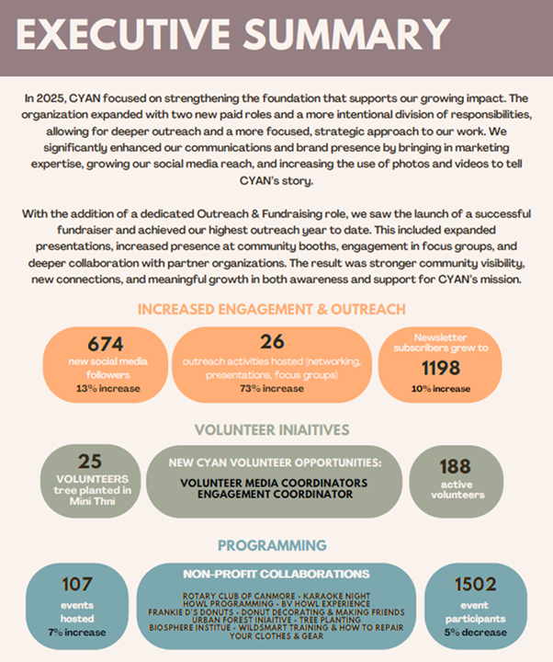

ECUMENICAL PRAYER SHAWL MINISTRY
Mona Mcintyre & Jeanette Aishford
Canmore prayer shawl group consists of18 active members. We continue to share our knitted and crocheted "woolen hugs" with those who have lost loved ones or are experiencing health challenges. We are very appreciative of Rev. Marco's support. He has left shawls at Bow River Lodge Seniors Lodge and delivers shawl in attractive gift bags as we knitters like to do. The Service of Light at Ralph Connor in December by Rev. Marco was very meaningful and 40 shawls went home with new owners. Unfortunately, the very annual generous gift of $2,000 by Crossway Community Church has been temporarily (we hope) cancelled as they endeavour to purchase the building their thrift store occupies.

FRIENDS OF CANMORE YOUNG ADULT NETWORK (FOCYAN)
Joy McMann and Ruben Nelson
In 2017, RCMCoF was the original sponsor of CYAN.
FoCYAN consists of: Ian Schofield, Ruben Nelson and Joy McMann from RCMUC and Laura Wellmann, from the Town’s FCSS. We are grateful for their continued support for CYAN.
Nicole continued to steer CYAN through 2025 with consistent leadership. It is striking how adeptly CYAN has been able to respond to trends and feedback by adapting its leadership as well as the programming it offers. You will see some of this in CYAN’s annual report.
FoCYAN offers support to Nicole by reviewing and discussing CYAN’s quarterly reports. FoCYAN also reviews and, in some cases, signs, CYAN grant and funding applications.
Our community of faith expresses its commitment to CYAN through donations, through use of meeting spaces, by being CYAN's fiscal trustee and by covering their bookkeeping costs.
Once again, we extend a big THANK YOU for all the CYAN staff and volunteers whether you are on the front lines or in the background. You are the ones who have helped CYAN’s events be successful. We also highlight Nicole’s role as Executive Director. Thanks, Nicole, for your commitment, time and energy for CYAN work. The success of CYAN is a tribute to your leadership.
Respectfully submitted,
Joy McMann and Ruben Nelson
Co-chairs of FoCYAN

FUTURES EXPLORATION
Joy McMann
The Futures Exploration Working Group planned and hosted an evening at Rundle on May 1, 2025 entitled, “Fall in Love with the Earth… Again.” It was co-hosted by The Biosphere Institute. The purpose of the evening was to lift the spirits of participants through music, story, meditation and conversation. As concern rises about how our modern ways of being and living are creating an existential threat to life on Earth as we know it, this evening provided opportunities to rekindle our gratitude for the many ways we and all life are nourished by the Earth and to explore the call to “fall in love with the Earth… again.”
Ariole Kesari Alei opened the evening with words of welcome and invitation, followed by an Indigenous Prayer and smudge by Tobias Ear. A moving rendition of “We are Standing on Holy Ground” was sung by the Ralph Connor Choir. Bart Robinson shared some of the story of his relationship with the Earth. Sarah Arthurs led a guided meditation before participants chose one of the following small group sessions: Talking/Healing Circle, Earth-Centred Meditation, or Climate Grief.
We’d like to thank all those who helped make the evening meaningful, those already mentioned plus Tanya Pacholok (Biosphere Institute) and Sim for coordinating the array of snacks.
The Futures Exploration group worked in partnership with Ariole Kesari Alei and Tobias Ear to offer two Talking/Healing Circles in Ralph Connor Memorial, besides the one that was part of Fall in Love with the Earth… Again. These circles provide a healing space of sharing and listening, particularly related to how we are impacted by and engaging with the state of the earth.
While Futures Exploration had planned to offer a second “Good Grief” evening in the fall of 2025, we, instead, turned our time and energy to the work of Into the Upper Bow Valley. See more in that report.
As an off-shoot of our work, Ruben and Allan secured funds to outfit the Upstairs room at Ralph Connor with technology to allow for hybrid meetings and presentations. The room is now set up and being used. For example, in the fall, we were a host-site for the Annual Environment and Spirituality Summit, whereby we showed live-streamed speakers, including Robin Wall Kimmerer. A few persons from the community joined us for these inspiring talks.
Once again, I thank Ruben for his knowledge and insight and Sim for her contributions to our conversations and plans. I value each of you and enjoy working with you.
Respectfully submitted,
Joy McMann
Chair, Futures Exploration Working Group

GREEN EXODUS
Sarah Arthurs
Green Exodus continues to emerge and move like water, finding ways within various communities, to step together into deeper intimacy and reciprocity with the Earth. A current project is to partner with the Inglewood Bird Sanctuary to host Birds and Words which uses poetry as a way for people to receive the gifts we experience as part of the Earth and to respond with something in return - fragments of noticing curiosity and delight! Our intention is to strengthen our awareness of our wovenness within the life of the Earth - groundedness and dependence.
We are applying for a grant from The Federation of Calgary Communities, partnering with the Calgary Climate Hub and hoping to partner with the Inglewood Bird Sanctuary. Tonya Lailey and I are planning to host two four week sessions in the spring and fall on 2026.
Warm regards,
Sarah

RECONCILIATION & RIGHT RELATIONS
Joy McMann
Indigenous Book Club
In honour of the 10th anniversary of the Truth and Reconciliation Commission we hosted two book club sessions. A huge THANK YOU to Donna for organizing these two evenings.
The first was Marie Wilsons’s “North of Nowhere.” Marie was one of three commissioners for the TRC. Liz Oscroft who had spent six years with the Truth and Reconciliation Commission (TRC) as part of the health support workers was our leader and facilitator for the evening. Lyall Gardiner, an adjudicator for the Independent Assessment Process which was also part of the Indian Residential Schools Settlement agreement, shared his experiences. Close to 50 participants attended with more than half from the community outside our church community. A couple of participants’ evaluations included the following comments:
“What a rich evening that was, I think I’ll be processing both Marie’s book and the experiences that Liz and Lyle shared for some time.”
“I was very moved by the book talk and presentations yesterday, thank you for facilitating the event.”
The second book was Sandra Hayes-Gardiner’s book “Crossing the River,” an unsettling memoir. Sandra grew up in The Pas, Manitoba, where the white settler community was on one side of the river and the Reserve was on the other. This book was her personal story of dealing with her racism and then her journey of Reconciliation. Sandra joined us for the evening and after she had shared more about her journey, Sandra invited the 30 plus attending to speak to their journeys. It was a very moving evening.
Red Dress and Orange Shirt Displays
We continued to acknowledge and bring attention to Red Dress Day National Day of Missing & Murdered Indigenous Women, Girls and Two-Spirited Peoples (MMIWG2S) on May 5. Red dresses were hung to recognize the pain and loss that loved ones, victims and survivors experience. Displays were also put up for Orange Shirt Day September 30 and National Truth and Reconciliation Week September 23-29. Thoughts, music and prayers were included in Sunday services as well as eye catching displays decorated the front of both Ralph Connor and Rundle churches. The displays were each up approximately one week and included QR code posters for people to have easy access to more information.
Thanks to Marg Suurallik, Ruby & Bill Fisher and all the helpers that put up and took down the displays. Your contributions do not go unnoticed.
R&RR Circles
Anyone interested in the work of R&RR was invited to join three discussion circles after church in the fall of 2025. Many persons joined those circles as we explored our own thoughts, concerns, experiences and journeys along the road to reconciliation. We plan to continue these circles.
Mitten Tree Campaign
The Christmas Mitten Tree campaign began in mid-November, and gifts quickly accumulated beneath the tree. By December 11, the church had collected a large assortment of children’s toys, books, and clothing, along with bedding, coats, gloves, socks, mitts, scarves, and many other practical items for mothers and their children at the Eagles Nest Stoney Family Shelter.
On December 14, following the church service, several volunteers gathered to organize the donated items. The next day, a group of eight enthusiastic volunteers carefully sorted the donations and packed them into bags and boxes in preparation for delivery.
On Tuesday, December 16, Laurie Patino, Director of the Eagles Nest Family Shelter, welcomed seven church volunteers. She and her staff assisted with unloading the donations. The team also delivered Wal-Mart gift cards purchased with cash contributions ($1,000) from generous church members. Laurie explained that these cards would be provided to women as they transition out of the shelter to help them purchase food. She also gave the volunteers a tour of the beautiful newly renovated facility, which had just completed a six-room addition and was expecting to house up to 50 women and children within the following two weeks. Laurie concluded the visit with an informative and inspiring presentation about the needs of Indigenous women seeking shelter and the services provided by the organization.
On December 7, following the church service, a Christmas craft market was held featuring jewelry by Sim, pies, and other items. The following week, Sim hosted an additional jewelry viewing in her home, with a generous percentage of sales supporting the Mitten Tree project. Proceeds from these Christmas sales, along with cash donations from church members, enabled the church to issue a cheque ($2,000) to the Iyahrhe Nakoda Food Bank.
After delivering the Mitten Tree donations to the shelter, church volunteers met with Michelle Beaver, Operations Supervisor of the Iyahrhe Nakoda Food Bank, to present the cheque. Volunteers then spent several hours assisting with the preparation of Christmas food hampers, which were delivered to Indigenous families in the area before Christmas.
The Mitten Tree campaign was a great success this year. The shelter deeply appreciated the toys, games, clothing, and gift cards, while the food bank expressed gratitude for both the financial contribution and volunteer support. Heartfelt thanks go to all church members whose generosity made this outreach possible.
We send out a big thanks to Bev Carrick for organizing the Mitten Tree Campaign.
Mini Christmas Markets
Two Sundays in December, Gordon Hall was buzzing with activity, laughter and brisk business, when we held two one-hour-long, very successful, Mini Christmas Markets after Church to raise funds for the Mitten Tree Project. Many Church members brought home-made donations of fabulous Christmas baking, pickles, cranberry compote, chocolate sauce, candles, art calendars, organic garlic, chocolate/nut candy, Christmas jewellery and decorations. We also sold wonderful knitting, donated by a Senior's Group in Edmonton!
The Markets raised $1262 and $513, respectively, for a total of $1775. A huge "Thank You" to all contributors (Ruby, Janis, Vicky, Sandy, Donna, Sue, Marg, Joy, Isabelle, Val, Tanya) and all buyers for their generosity; without you, this money could not have been raised.
And it was very Christmassy and fun; a wonderful group effort, thank you!! Sim's jewellery and stones home-sales (30% of which was donated) got off to a slower start, but thanks to Donna, two full carloads of shoppers showed up for this sale on December 11, and Sim's family room was buzzing with laughing, chatting and shopping RCMUC ladies and their friends. They even brought snacks and we had a lovely coffee time afterwards. The home sales raised $368, of which $226 went to the Mitten Tree Project and $142 to the Right Relations Group at RCMUC.
These efforts illustrate how much we can achieve and how much fun we can have, when we work as a group. I am so grateful to all of you! Thank you!! - Sim Gascoyne
We acknowledge and thank Sim for her efforts to making the mini-Christmas market happen and for her commitment to Reconciliation & Right Relations. Thank you, Sim!
Indigenous Library
I want to also thank Joan Von Engelbrechten for cataloguing our Indigenous library. Many great books have been donated or loaned. Please feel free to borrow and read some of these books.
Thank you!
Lastly, I’d like to thank all those who participated in the various activities of Reconciliation & Right Relations. Whether you organized, participated, donated or helped, we are in this work together. Thank you for your support.
Respectfully submitted,
Joy McMann
On behalf of the R&RR Team

RUNDLE THRIFT
Sally Macdonald
Chair
We are grateful for the continued support of the Bow Valley Community since we reopened in February 2025. The Thrift continues to offer low priced household items and clothing to the community. We also give free items to those in need who come into the shop and also thru our partnership with the YWCA.
The thrift shop has continued to bring in significant revenue to RCMUC. (Please see Treasurer’s Report for financial figures). We hired two part time managers last March to operate the thrift shop with four paid staff and approximately 15 volunteers with varying time commitments. Saturday openings started in August to increase our opening days to five/week. We continue to develop strategies to grow our social media profile and possible Monday openings for the next year.
A huge thank you to our wonderful church volunteers who support the Thrift in various capacities: Bill and Ruby Fisher, Rod Sullivan, Bill Rowe, John Snoddy, Joy McCann, Ian Brownlie, Sim Stroes Gascoyne, Carole Rowe, Heather Snoddy, Sue Nicolls, Faye Forbes Anderson and Joan.
Respectfully,
Sally MacDonald.

THE WORLD IS OUR NEIGHBOUR (TWION)
Ian Brownlie
This has been a harrowing, soul crushing year for the family.
After months of pleading and begging, Canada issued new travel authorities (single journey passports) and Confirmations of Permanent Resident status on May 22. These had an expiry date of July 6, which coincided with expiration of their health clearance documents.
Immediately, the family began lobbying the Nepal government to specify the exact price of the overstay penalty. In Canada, we served notice to the manse tenants that they would need to leave by July 31, and scrambled to find temporary accommodation for the family till August 1. The tenants graciously offered to vacate in mid-June, which gave us time to clean and prepare the house for the family.
As the days dragged on, we began pleading for an extension to the document expiry date. Finally, Nepal specified the amount required on June 26. We fought with two banks in Canada to wire the funds, but succeeded June 27 (Friday before our long weekend). Miraculously, the funds arrived and were cleared in Nepal by June 30, and the family paid the overstay charge, gaining official receipts.
The Home Minister was apparently out of office that day, so all official documents were retained with the proof of payment so that he could sign an exit permit, which is required to leave the country.
The International Office of Migration booked flights to leave July 5. The family gave away everything they could not pack, packed their bags and cleared out their apartment. Each day when they went to the Home Ministry office, they were turned away because the minister had not returned or was too busy.
July 4, UNHCR called the family saying everything was settled and to collect the permit and their documents at 3pm. Bags were sealed, transportation to the airport organized and the family tried to sleep before their 30 hour journey, while Pastor Bhatti returned to the office. Yet again, he was turned away. The Authority to Travel and other documents expired.
We immediately informed IRCC (immigration Canada) to request new documents. Eventually they replied, requesting the original, now expired documents be returned. The Home Ministry in Nepal refuse to release them. Subsequently there were massive protests and riots in Kathmandu which resulted in severe damage to government buildings, and the resignation of the President and Prime Minister. We have yet to be able to determine if the documents survive.
The family is understandably stressed but overcoming depression. They’ve been forced to move to an even smaller apartment, have experienced an accident which required surgery, lived through curfews imposed after the riots and struggling to find food and yet they carry on. They have a tremendous faith and find strength from their congregations in Kathmandu, and by volunteering for them. They provide support to several refugee families through one of their churches. Not legally able to work, the “children” have taken online work (like selling roofing to people in Wisconsin and coaching Chinese youth in English).
We continue to lobby Canada’s Minister of Foreign Affairs, Minister of IRCC, the High Commissioner and Immigration Offer in New Delhi for help.
Please hold the family, and other refugees worldwide, in your prayers.
Ian Brownlie
Worship
EVENSONG
Jan Tissandier

Deep the love, the love that calls us on. ~ Carolyn McDade

Through song, word, and silence, Love invites us to walk the path of faith with the Evensong community. Since these Wednesday evening services began in September of 2001, they have been a place to gather for contemplation and companionship. Throughout those years, a circle of lay people have stepped up to lead Evensong, following the liturgical calendar and the seasons of the earth.

In 2025, Evensong assumed leadership of the Easter morning riverside service, under the capable direction of Joan von Engelbrechten. In June, Evensong held sacred space for the Covenanting Service between Rev. Marco Ste. Marie and Ralph Connor Church, a special service of welcome and promise.

This past year, from Epiphany to Pentecost, we alternated weeks with Sacred Circle, which eased the demands on leaders of both program strands. Resuming services in October after a summer pause, Evensong is hosting three weeks per month. We continue to be deeply inspired by the wisdom of our circle of leaders: Joy McMann, Judy Archer, Judith Maxwell, Eric McAvity, Marni Virtue, Heather and Alan MacFadyen, Jackie Baker, Joan von Engelbrechten, and Femmeke Holthuis.

Submitted with deep gratitude for this contemplative ministry ~ the leaders and all who find their way to Evensong.

Jan Tissandier

REPORTS REGARDING PHYSICAL ASSETS
BOARD OF TRUSTEES
Carole Rowe
Chair RCMUC Board of Trustees
This is the report of your Board of Trustees for the year ended December 31, 2025.
There are seven locally elected trustees (Carole Rowe, Barbara Profitt, Jim Ridley, John Thorburn, Gus Campbell, Marlo Reid and Brian James) who meet quarterly with the active advice and counsel of the Minister who is, by United Church policy, also a Trustee.
Copies of the minutes of all Trustee meetings are available from the Chair Carole Rowe or the Church Office.
The Trustees provide oversight for $6 million of assessed properties including both Ralph Connor and Rundle Churches and the Rundle Manse. We report that appropriate insurance coverage is in place.
Another primary responsibility of the Trustees is to manage the portfolio of investments purchased with the proceeds from the sale of the Canmore manse. Specific investment options and recommendations to be made by an investment advisor reporting quarterly to the Chair of the Board of Trustees who in turn will lead decision making on investments by the Board.
The portfolio value at December 31, 2025, was $696,903. I am pleased to report that this year the portfolio had a positive return of 18.56%, 3 years 13.18%, 5 years 8.80%, 10 years 8.27%. This year the Trustees provided $23,000 towards general operations of the Church. Annually the amount provided to the Church will be increased based upon the Alberta All items CPI index.
We carefully need to balance the need for growth with the need to have a stable cash flow for the Church. The equity markets have been increasing to all-time highs, pushing the equity portion of our portfolio higher. We are rebalancing the portfolio and investing approximately 55% (+ or -10%) of the investments in Canadian Equities and approximately 45% (+ or -10%) of the investments in Canadian Fixed Income Securities. Keeping approximately 45% in fixed income is to provide stability to the portfolio.
A copy of the portfolio is available for viewing by any member of the congregation.
In discussion with our investment advisor all potential investments are subject to an ESG (Environmental, Social and Governance) filter. As socially conscious investors we will receive recommendations based on a set of standards for a company’s behavior.
A loan for $87,000 was secured from the United Church of Canada for 5 years. The loan was approved to assist, if needed, with three capital projects - the boiler replacement and flat roof repair at Rundle and external painting of Ralph Connor Canmore. The loan is interest free for the first year and at a low interest rate thereafter.
During 2025 two significant capital projects were completed.
A new boiler was installed at Rundle replacing the 1927 original one and the exterior of Ralph Connor was repainted. Rundle requires repairs to the flat roof and continued masonry work on the walls. The roof repair work that was scheduled in 2025 was postponed to 2026 due to the unavailability of contractors.
The Rundle Manse was leased on a short-term basis to a local hospitality group for staff housing and since October has been providing a temporary home for a refugee family in
co-ordination with the Bow Valley Refugee group.
A Memorial Fund Policy was created in 2018 with all responsibility for the funds to be managed by the Church. The Policy had never been implemented and the Trustees continued to manage the memorial funds. In January both Council and Trustees decided to enact the policy and the balance of the Memorial funds held by the Trustees of $7410 were transferred to the church accounts.
In the coming year an exciting development will be the re-imagining of the Rundle Sanctuary. The Rundle Sanctuary Team Committee is passionately working to make the space more flexible for multiple users.
The Trustees supports the moving forward of a solar panel project (in partnership with Bow Valley Green Energy Co-operative) at Rundle.
Barbara Proftt will be retiring as a Trustee after the AGM. We thank Barb for her long, much valued contribution to the Board of Trustees.
Respectfully submitted
Carole Rowe
Chair RCMUC Board of Trustees

BUILDING/HERITAGE COMMITTEE REPORT
Paul Elfner
Chair

The Building Heritage Committee arose on an ad-hoc basis to complete our “Accessibility Project” for the Canmore Building and further capital work as needed. The Canmore project was completed in June 2023 and we hope everyone feels it is serving our needs well.

Interest in the Canmore space has been reportedly increasing, and our continued endeavour as Community of Faith will be to promote it for the betterment of us and the community at large. Our legacy must ultimately be self-sustainability that will allow the building to continue operating as a community asset.

The focus has now turned to the Banff building. During the past year, the 1927 boiler system has been replaced with a new system which should efficiently carry us through for the next 25+ years.

A separate ad-hoc committee for Rundle Sanctuary Visioning (RSV) has been formed with the mandate to consider how to evolve and animate the space again. Already they have chosen to remove the pews and replace with stackable seating- more changes are likely – stay tuned!

Depending on direction from the RSV committee, it may be time to consider the Rundle building in its entirety with an eye to possible upgrade to infrastructure such as kitchen space, accessibly, fire and life safety, security, building envelope, electrical systems, and more.

Respectfully submitted – Paul Elfner -Chair

CHURCH HISTORIAN REPORT
Karen Fraser
2025 marked the 100th year of the formation of the United Church of Canada (UCC) as a result of church union of the Methodists, Congregationalists and the majority of Presbyterians across Canada. Rev. Charles Gordon (pen name Ralph Connor) who was a Presbyterian missionary in the North West Territories and the Minister in Canmore when our sanctuary was built in 1980-81, became a strong advocate of church union. His significant influence in Canmore was reflected in the early decision of the Canmore Presbyterians to support the union and adopt the new name, Canmore United Church (later renamed Ralph Connor Memorial United Church in 1942).
Further, the Methodist Church in Banff and a number of Presbyterians seized the occasion of church union to plan and build a new Sanctuary and on July 1, 1927, the present sanctuary of Rundle Memorial United Church was dedicated. We have a long and proud history of Christian witness in Canmore and Banff.
The 100th anniversary of the United Church of Canada was celebrated across Canada in June 2025. Rev. Marco held an engaging anniversary service which marked significant milestone events of our church throughout the century. It was particularly interesting to hear from members of our community of faith about certain events which were meaningful to them. We also invited visitors and locals alike into our Churches during June followed by fellowship with a celebratory cake and other goodies! Thank you to everyone who participated.
We will continue to honour the faith of our ancestors by marking these important anniversaries. We marked the 135th anniversary of the Sanctuary at Ralph Connor Memorial on January 25, 2026. We are already planning to mark the 100th anniversary of the Sanctuary of Rundle United on July 1, 2027.
We now have a full set of story boards with pictures and text which sit on easels at Ralph Connor to tell our story when we host open houses. Locals and visitors from far and wide appreciate the quiet of the Sanctuary. Some have connections to the church and we often have visits from individuals or family members who were married in the Sanctuary. We have even had visits from descendants of Charles Gordon (Ralph Connor).
The land title for Rundle Memorial is in the name of the United Church of Canada and not in the name of the local trustees. Ian Schofield and I undertook research at the Whyte Museum and the Provincial Archives to attempt to find out why the title of Rundle Memorial Church is in the name of the United Church of Canada rather than the local trustees. We also kept a lookout for stories and pictures to augment our existing collections in furtherance of our project to develop story boards for future Open Houses at Rundle Memorial.
In addition to marking anniversaries of church life in Canmore and Banff we provided Moments in History to provide a local lens on events. We continued our practice of making a short presentation on Remembrance Sundays on the lives of the young men of our two churches, who gave the ultimate sacrifice and who are memorialized in our Sanctuaries.
For those with an interest in local history and history of the Chrisitan Church please join us to help us bring our proud history alive.

ANNUAL FINANCIAL REPORTS AND BUDGETS
TREASURER’S REPORT FOR 2025
Bill Fisher
Attached to this report are two financial statements: Statement of Activity by Class (often called a Profit & Loss statement) and a Statement of Financial Position (often called a Balance Sheet). Here are the highlights:
Statement of Activity by Class
This statement documents all the income and all the expenses that were accounted for in 2025. There are six columns in the statement that represent different streams of income and expenses.
- The Special Funds column is where our M&S offerings and expenses can be seen. It is also where we show income directed at specific outreach ministries (e.g. Right Relations, Future Explorations, etc.). You will note that the TWION account had annual expenses over income of $59,466. This program has its own bank account separate from our main chequing account and it does not impact our operations. If you look at the Statement of Financial Position (Balance Sheet) you will see that the TWION account still has a balance of over $22,000.
- For the remaining outreach ministries in the 4600 series of accounts, the funds remaining at the end of the year are transferred to their respective deferred funds that can be found on the Statement of Financial Position.
- The Projects column was created to track our major capital projects. At our AGM in 2025 we presented a Long-term Capital Plan. In 2025 two projects were completed. The exterior of Ralph Connor was painted at a cost of $12,649. A portion of that cost ($3860) was offset by a grant from the Province of Alberta. The other major project was the replacement of the boiler at Rundle at a cost of $106,578. We secured a loan from the UCC ($87,000) and transferred $10,969 from the Building Fund account to cover most of the cost.
- The Rundle column represents a few building expenses (e.g. replace and upgrade Thrift Shop shelving, storage and change rooms). They need to be tracked separately as part of our insurance claim.
- The Trustee Funds column outlines investment income and at the bottom of the statement the change in Fair Market Value of Investments. It is a “negative expense” of $79,468 and consequently gets added to the income.
- The Operations column outlines where the bulk of our day-to-day income and expenses can be seen.
  - Offerings were over $140,000. This is about $4000 less than 2024.
  - Rentals were over $25,000 which is similar to 2024.
  - Thrift Shop proceeds were over $215,000. This is $181,000 more than in 2024 due to the Thrift Shop fire and resulting closure for nine months.
  - Income from weddings and funerals was $6000 which is higher than in 2024.
  - The Trustees contributed $23,000 towards the income of the church.
  - We received the second tranche of our business interruption insurance claim $77,445, which covered the August – December 2024 period when the Thrift Shop was closed.
  - Total gross operating income was $483,808.
  - Ministry and Personnel expenses were about $170,000. This includes the payroll for our clergy, Communications Manager and our A/V Technician.
  - The Thrift Shop payroll was about $62,000.
  - Musicians’ services were $25,000.
  - UCC assessment was $10,068.
  - Office supplies, telephone, equipment purchases were $17,782. This is similar to 2024.
  - Professional service fees were about $25,000. This is $6000 less than 2024.
  - The building operating costs for both churches and the manse were about $39,641. This is about $7000 less than 2024.
  - Utility costs were $22,625.
  - The Thrift Shop spent about $7300 on supplies and fees associated with credit card transactions.
  - Total operating expenses were $394,162.
  - From an operations perspective, our income was $96,000 more than our expenses in 2025.
Statement of Financial Position (as of December 31, 2025).
This statement outlines our assets (current cash, investments and property/equipment/furniture) and our liabilities (accounts payable, loans and deferred revenue funds).
- We have about $293,000 in cash and GIC’s and over $708,000 in investments managed by our Trustees.
- Our liabilities are primarily associated with our outreach and ministry deferred funds. A “deferred revenue” refers to funds that have already been received by a ministry but have not yet been spent, hence they are a liability. These non-current liabilities total over $153,000 with about $81,000 associated with our UCC loan. We have five years to pay back the loan and are presently making payments of $1525/month.
- Our net income for 2025 was over $25,000.
Notes:
- Our financial statements are currently being reviewed by the accounting firm Baker Tilly. I am confident that the statements we have provided in this Annual Report are accurate but there may be minor changes.
- Nearly all the church’s financial work is completed by our Bookkeeper, Patricia Roozendaal. Without her dedication and attention to detail, it would be impossible for me to undertake the work as Treasurer.
- Our payroll work is done by Dianne Melton. Her job is to ensure that people get paid correctly and on time ... and she does just that!
- I also want to thank Joy McMann, Rick Anderson and Mona McIntyre for working as signing officers and Carole Rowe and the Trustees and the Stewardship Committee. You all make my work easier to accomplish.
Respectfully submitted by,
Bill Fisher
Treasurer

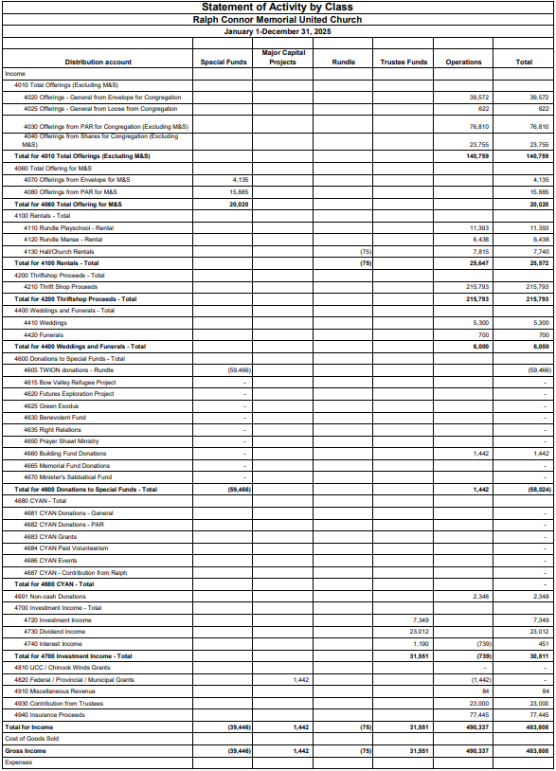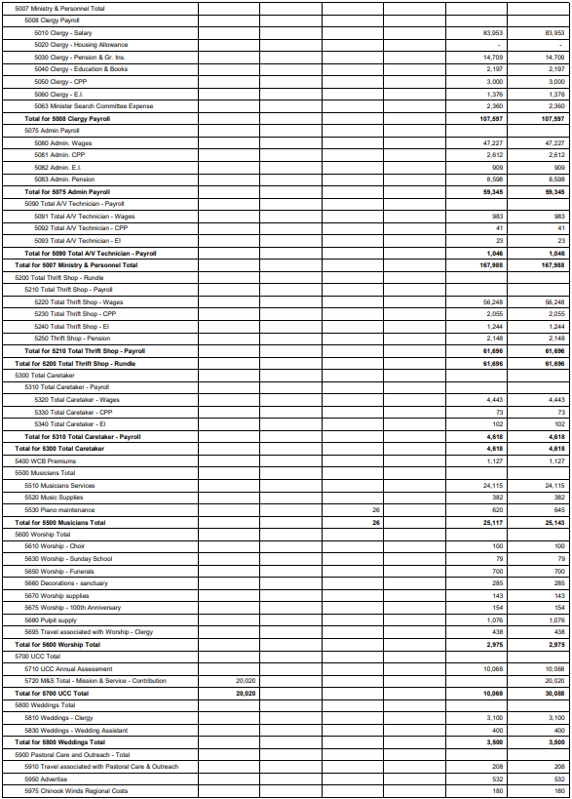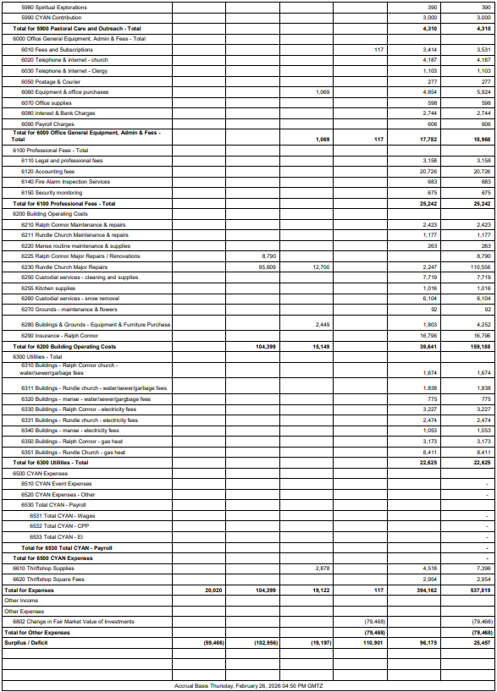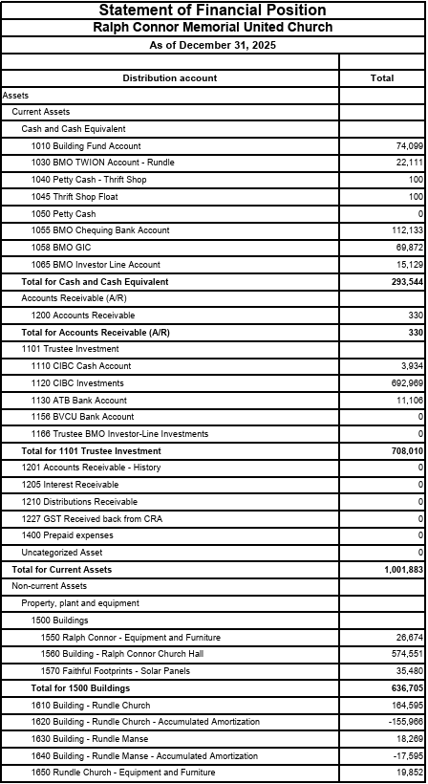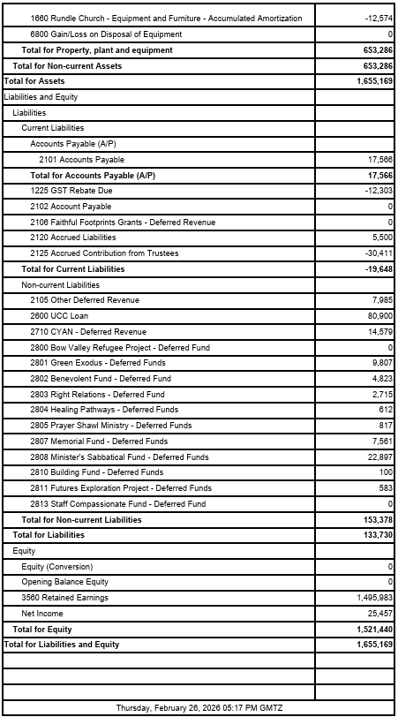

PROPOSED 2026 OPERATING BUDGET
NARRATIVE SUMMARY

Introduction
The attached line-by-line operating budget forecasts the incomes and expenses associated with the operations of the church. It also includes the incomes associated with our M&S offerings and outreach ministries (e.g. Futures Explorations, Right Relations, Benevolent Fund, etc.) that are anticipating receiving funds (e.g. grants, special offerings) in 2026. Below are some of the larger variances from previous year’s income and expenditures.
Projected Income
- We are forecasting total income at $445,819.
- Income from Offerings is anticipated to be $149,500. This is about $6000 greater than in 2025.
- I am not forecasting any manse rental income in 2026 so total rental income will be about $5000 less than 2025.
- I am estimating our Thrift Shop proceeds at $231,000. This is $16,000 more than 2025 and is based on 12 months of operation vs. 10.5 months in 2025.
- Although not tracked as an operating income or expense, I have also presented the income associated with donations and grants to TWION, Futures Explorations, Benevolent Fund, Right Relations, and Building Fund. In each of these accounts, specific donations are anticipated to be made only for these funds. Consequently, these funds (11,700) are not available to cover operating expenses. The Minister’s Sabbatical Fund is an exception and will be covered by general operating income.
- On the advice of our accountants at Baker Tilly, the “Contribution from Trustees (account 4930) should not be considered as “income” as those funds are already recognized in our Balance Sheet.
- The church should be receiving a final business interruption claim payment and a “loss of contents” from the 2024 fire but it is difficult to anticipate when this will arrive. Consequently, I have not provided a figure under account 4940.
Projected Expenses
- I have forecast total expenses to be $467,689.
- The Ministry and Personnel expenses are projected to be $193,000. The increase over 2025 is based on having an A/V Technician (live streaming worship services) for the entire year.
- The Thrift Shop payroll is similar to 2025.
- The Musicians’ budget is about $5000 more than last year.
- Ralph Connor’s UCC assessment is about $4000 greater than 2025. This figure is closer to previous years.
- The Pastoral Care and Outreach budget is $10,000 greater than 2025. Church Council requested that the Advertising Budget be increased by $4000 and a new program “Outreach Initiatives” be created and funded at $5000.
- Office expenses and Professional Services are projected to be similar to last year.
- Building Operating costs are expected to be $13,000 higher although it is difficult to anticipate minor repairs (e.g. Ralph Connor elevator repairs). Insurance Costs are expected to be about $3000 higher than last year.
- Utilities are anticipated to be similar to 2025.

Project Operating Surplus/Deficit
- This Operating Budget projects a deficit of $21,870.
Some final thoughts …
I will be monitoring our operating budget vs. actual expenditures monthly and will be providing the Executive / Church Council with my assessment as the year progresses.
This is an Operating Budget. It does not include major capital projects that need to be implemented in 2026. Those projects are identified in the proposed Long Term Capital Plan and have a different source of funds.
This proposed Operating Budget reflects amendments suggested by the Church Council on February 18, 2026 and the recommendation from Baker Tilly to not recognize “Contributions from Trustees) as a source of income.

Respectfully submitted by,
Bill Fisher
Treasurer

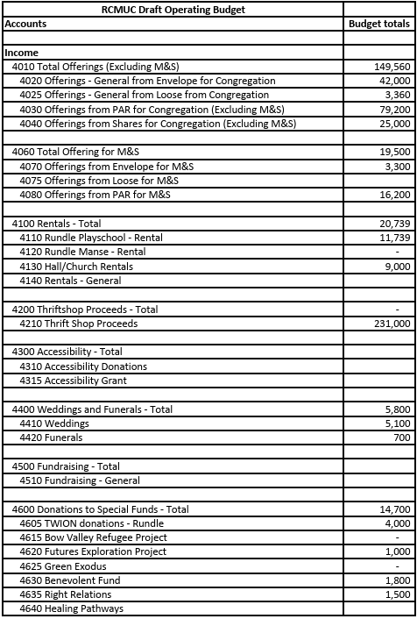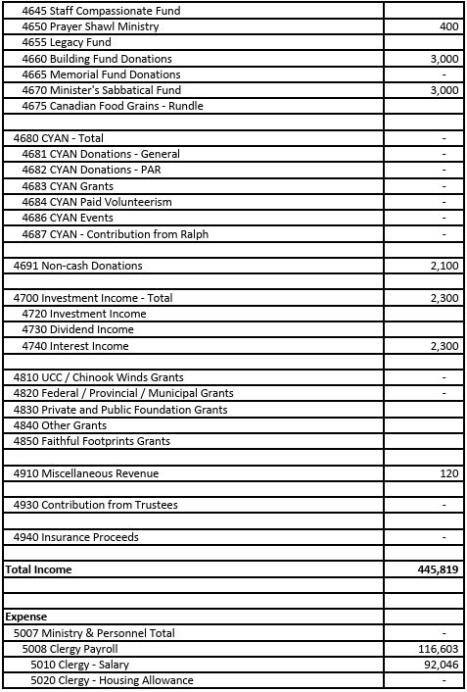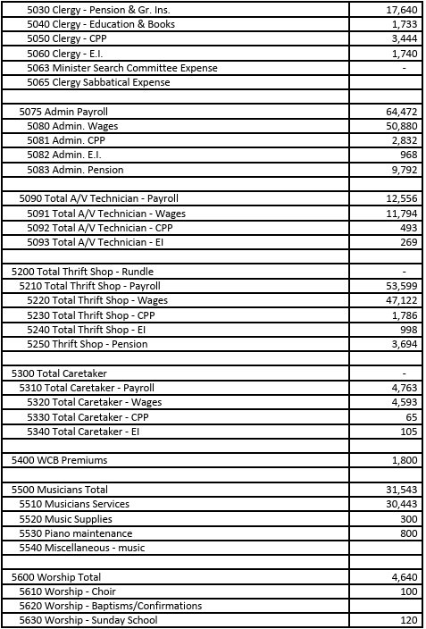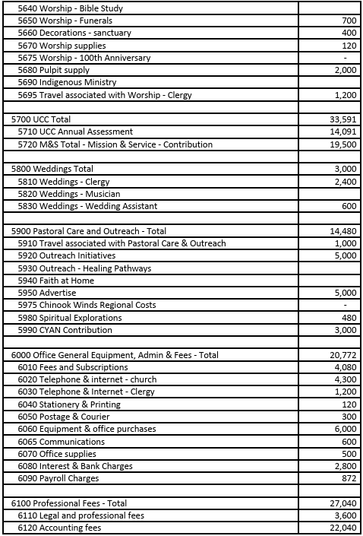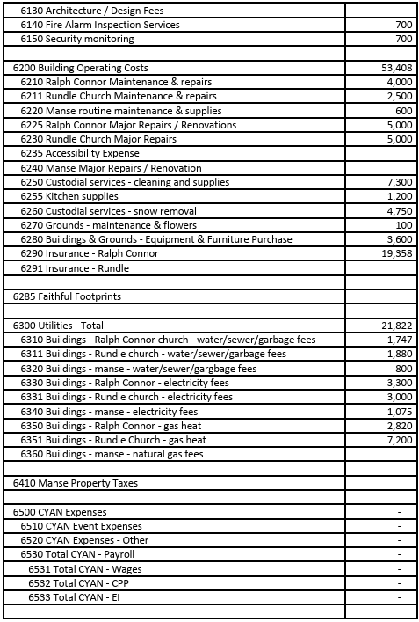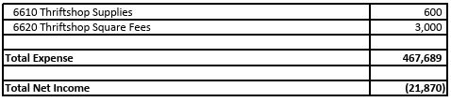
Ralph Connor Memorial United Church
Proposed Long-Term Capital Plan
Annual General Meeting
March 22, 2026
Background
Our congregation has fixed assets (land, buildings and equipment/furnishings) with a replacement cost of over $6,000,000. In September 2024, the Church Executive approved the development of a Long-Term Capital Plan. Its purpose is to develop a reasonable approach towards repairing or replacing components of our buildings and equipment/furnishings that corresponds to their normal useful life. By taking a long-term perspective, we can begin to better understand and prepare for larger projects that will need funding, perhaps not immediately but several years from now.
Members of the congregation, with experience in managing our properties and their historic character, met in January 2026 to review and update the Long-Term Capital Plan. The Trustees had a subsequent meeting to review the proposed plan. Six major capital projects are proposed to begin in 2026. Some of the projects have solid cost estimates based on discussions with contractors, while others are at a conceptual stage and require some pre-design and design work before any construction or installation can be approved.
- Rundle Flat Roof Replacement
- This capital project has been a priority for the last two fiscal years but securing a contractor to complete the work has been difficult. Given the urgent nature of this project, a contractor has been engaged, and work is anticipated to begin in March 2026.
- The estimated cost is $30,000 in 2026.
Rundle Flat Roof Replacement | 2026 | 2027 | 2028 | Comments
Remove and replace all membranes  Install cap flashings  Install new drain inserts  Replace shingles on shed | 30,000 |  |  | Contract signed, work is weather dependent.

- Masonry Wall Repair
- The Pinchin Report (2022) noted that there was a need to repair the southwest corner masonry wall of the Rundle Sanctuary. At the time, it was considered a high priority, but little action has been undertaken to assess the extent of work required nor provide an estimated cost.
- It is recommended that $5000 be approved for an assessment of the situation by a qualified contractor who can examine any water infiltration, stone masonry cracks and other issues, as per the Pinchin Report.
- The contractor will be expected to provide an estimate for the actual repair work and whether it can be deferred to 2027 or beyond.
Masonry Wall Repair | 2026 | 2027 | 2028 | Comments
Examine water infiltration  Examine masonry cracks  Provide estimate of actual repair | 5,000
Repair damaged masonry and foundation |  | 25,000 |  | Could work be deferred to 2027 or 2028?

- Rundle Sanctuary Upgrade
- The Sanctuary Planning Team recommends removing the pews and replacing with chairs to create a more flexible and multi-purpose space for events, concerts, workshops, etc. A new church in Calgary has agreed to purchase and remove the pews in late March / April. Church Council has approved the purchase of 50 stackable chairs and storage carts (estimated cost $15,000).
- The Sanctuary Planning Team has also been directed to develop a plan for the Rundle Sanctuary, Lonsdale Lounge and upstairs kitchen. The plan, developed with an architect, should address “full accessibility” and meet the vision for this space (estimated cost $10,000).
- Depending on the delivery of a suitable plan, an additional $25,000 would be provided in 2026 for final design and construction of an accessible washroom.
Rundle Sanctuary Upgrades | 2026 | 2027 | 2028 | Comments
Remove pews and replace with chairs | 15,000
Develop plan for Sanctuary, Lonsdale Lounge, kitchen, front and rear entrance | 10,000
Construct accessible washroom | 25,000
Additional upgrades |  | 25,000 | 25,000
- Solar Panel Installation on Rundle Church and manse
- This project is to install solar panels on the Rundle Playschool roof. Ralph Connor will own the solar array. Installation costs are about $25,000 and will be partially offset by grants. It is proposed that we would enter into an agreement with Bow Valley Green Energy Cooperative for maintenance and monitoring work.
- Six spruce trees along the east side of the manse will need to be removed to optimize the effectiveness of the solar panels. The church has reached out to the Town of Banff to determine whether the trees are on the church’s lease. If the trees are on our lease, $5000 will be required for their removal. This would also be prudent from a “Firesmart” perspective.
- Additional electrical engineering work will be required to upgrade the existing electrical panel. Estimated cost is about $10,000.
Rundle Solar Panels | 2026 | 2027 | 2028 | Comments
Install panels | 25,000 |  |  | Grant opportunity
Upgrade electrical panel | 10,000
Remove spruce trees | 5,000 |  |  | TBD with Town of Banff
- Gordon Hall Kitchen
- This project is being advanced from 2027. It includes the replacement of the existing countertop, sinks, cabinets and determining whether the existing dishwasher can be placed at counter height vs. purchasing a new unit.
- An assessment is underway to determine what is the highest priority work that can be completed in 2026 and what other upgrades would be possible with future funds, either available in 2026 or 2027.
Gordon Hall Kitchen | 2026 | 2027 | 2028 | Comments
Replace countertop  Replace sinks  Assess Dishwasher situation  Upgrade cabinets | 25,000
Other additional work |  | 10,000 |  | Some work could be advanced to 2026
- Rundle Security
- An assessment of the interior and exterior door locks is required given the multiple uses of the Rundle church by Rundle Playschool tenants, Thrift Shop staff/volunteers, short term renters, special event organizers, etc. Once complete, the locks will need to be upgraded.
- An assessment of emergency communication system (fire, forced entry, etc.) is needed and the necessary changes completed.
Rundle Security | 2026 | 2027 | 2028 | Comments
Assess and replace interior and exterior door locks.  Assess and upgrade emergency communications systems | 10,000 |  |  | Request funding from Trustees
Funding the Long-Term Capital Plan
In February 2026 a Draft Long-Term Capital Plan was presented to the Church Council. The total funding to achieve the six projects is $160,000. Given that some of the projects require additional planning and design work, the Council suggested that total funding up to $134,000 be approved for these major capital projects. Currently the Building Fund Bank Account has a balance of $124,000. The church also has access to a $50,000 GIC that is dedicated to major capital projects.
The following projects have already been approved due to their urgent nature: $15,000 for stackable chairs and carts at Rundle; and $30,000 for Rundle Flat Roof Replacement. As design and cost estimates are firmed up, the other projects can be approved by the Church Council / Executive. Some projects may not advance as quickly as proposed. Consequently, there is considerable flexibility in the Long-Term Capital Plan to move at a pace that does not exceed our total funding ceiling. If project approvals are anticipated to exceed $134,000, the Treasurer will present options to the Church Council / Executive for their review and decision.
Below is a table outlining the priority projects over the next six years.

Project | 2026 | 2027 | 2028 | 2029 | 2030 | 2031 | Comments/ Priority
Rundle Flat Roof | 30,000 |  |  |  |  |  | Urgent - high
Rundle Masonry | 5,000 | 25,000 |  |  |  |  | Pinchin Report - med
Rundle Sanctuary | 50,000 | 25,000 | 25,000 |  |  |  | Facilitate better use
Gordon Hall Kitchen | 25,000 | 10,000 |  |  |  |  | Rotting counter - med
Rundle Solar Panels | 40,000 |  |  |  |  |  | Energy Saving Op
Rundle Security | 10,000 |  |  |  |  |  | Request Trustees fund
Racine Hall windows |  |  | 4,000 |  |  |  | Very old - med
Gord Hall windows |  |  |  | 40,000 |  |  | Leaking - low
Travis Hall windows |  |  |  |  |  | 15,000 | Old and leaking - low
Travis Hall Doors |  |  |  |  |  | 3,000 | Old and leaking - low
Lonsdale windows |  |  |  |  | 12,000 |  | Old and leaking - low
Total | 160,000 | 60,000 | 29,000 | 40,000 | 12,000 | 18,000

Respectfully submitted by,

Bill Fisher
Treasurer

BOW VALLEY REFUGEE PROJECT

In 2025, the Bow Valley Refugee Project welcomed a family of three from Syria to the Bow Valley. The group supported their arrival in Canada, including funding their international travel and helping them settle into the community. Over the course of the year the family has made significant progress establishing themselves. One parent has secured employment and is able to provide the family's day-to-day needs. Our volunteers continue assist with language learning opportunities and in accessing all available supports.
One bright point in working with this family has been their four year-old son, who has boundless energy and a strong personality. He has started a preschool program and is very happy there. He is picking up words quickly and doesn't want to leave at the end of the day.
Housing for the family has been generously provided by Rundle United. This support has been an important of establishing their lives here during their first year in Canada. We expect another family to arrive from Nepal, who would then need the residence provided by Rundle United. BVRP would likely need to assist the current residents with rent while they continue to improve their English language skills and the second parent seeks employment. The new family has been approved for travel but have been delayed indefinitely due to the unstable government in Nepal. As a result, this possible additional cost is not reflected in the budget.
BVRP is raising funds to support its obligations through 2027, when it expects a new group from Afghanistan to arrive. A film screening and fundraiser is planned for June.

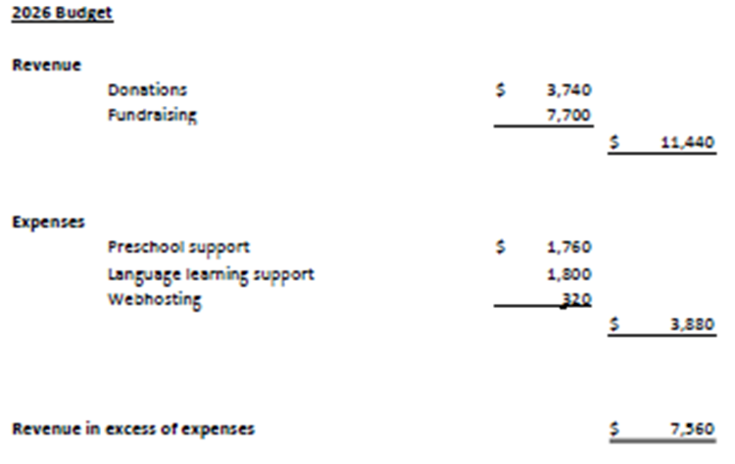
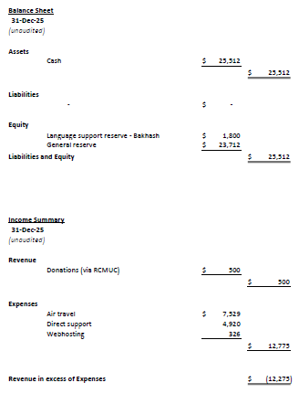

CANMORE YOUNG ADULT NETWORK
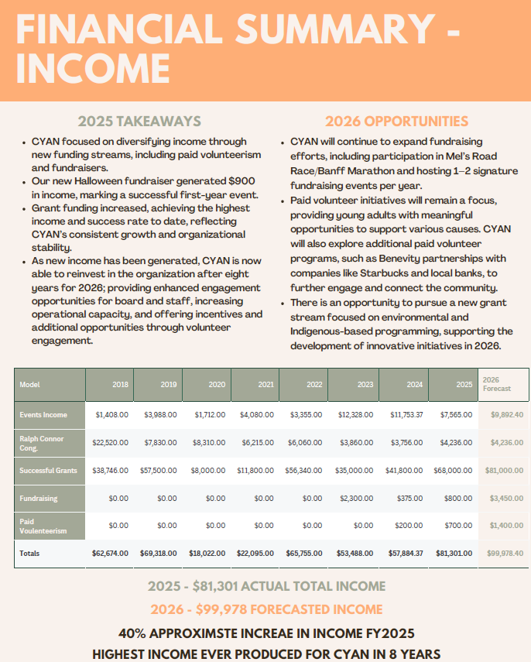
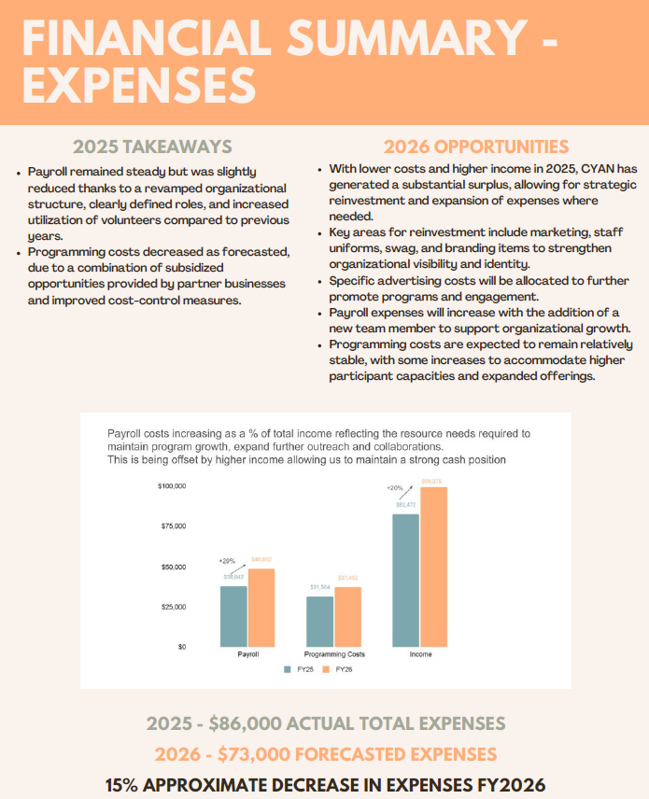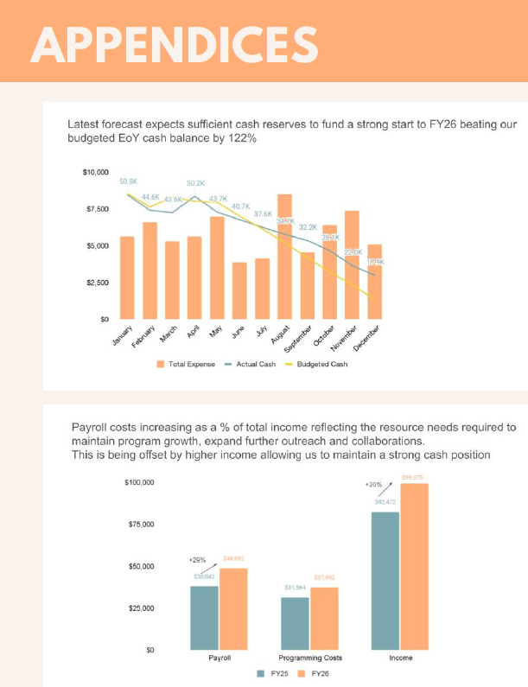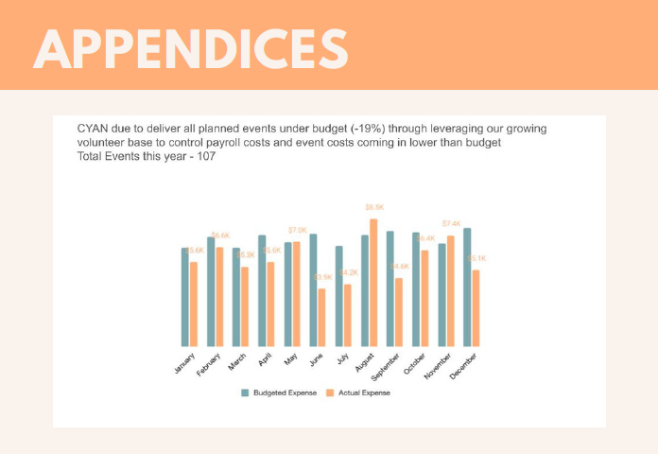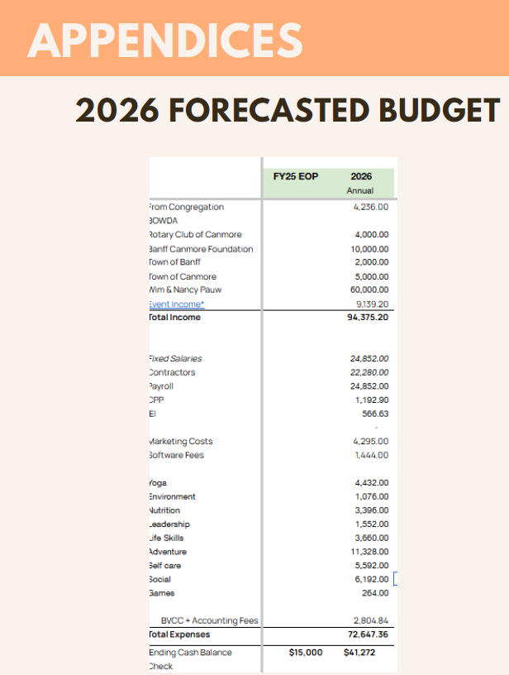

GREEN EXODUS

As of December 31, 2025 the balance in the Green Exodus acocunt was $9, 807.46

The normal expenditure rate is $1,000.00 a month for fees for the staff of Green Exodus.

Sarah Arthurs has informed us that she will not likely need our support as her fiscal trustee once these funds are expended. She has secured the services of a Calgary charity for the new funds she will secure for the program. Therefore, for our purposes, the program will end in the fall of 2026.

Since Greg Wooley left, Ruben Nelson, Secretary, has been the authorizing agent on our behalf for the expenditure of these funds. He will continue inthis role until the funds are expended.

Ruben Nelson
March 19, 2026

